+



**EQUELLA® Bulk Importer**

**User Manual**

Version 4.71



June 2015 edition.

Information in this document may change without notice. EQUELLA® and its accompanying documentation are furnished under a non-disclosure, evaluation agreement or licence agreement. Copying, storing, transmitting, or otherwise reproducing the software or this document in any form without written permission from Pearson Inc is strictly forbidden.

All products, other than EQUELLA®, named in this document are the property of their respective owners.

Property of:

  
Pearson Inc1330 Avenue of the AmericasNY 10019USA

**Contents at a Glance**

1 Introduction 7

2 Installation and Start Up 9

3 Quick Start Guide 11

4 Basic Settings 14

5 CSV File Format 17

6 Running the Import 52

7 Appendices 71

Table of Contents

1 Introduction 7

1.1 Knowledge Required to Use the EBI 7

1.2 How the EBI Works 7

1.3 Technical Stuff 8

2 Installation and Start Up 9

2.1 System Requirements 9

2.2 Windows® Installation and Start Up 9

2.3 Macintosh™ Installation and Start Up 10

2.4 Linux Installation and Start Up 10

2.5 Compatibility with Previous EQUELLA Bulk Importer Versions 10

2.6 Upgrading to the Latest Version 10

3 Quick Start Guide 11

4 Basic Settings 14

4.1 Connections Tab 14

4.2 CSV Tab 15

4.3 Options Tab 16

4.4 Log Tab 16

4.5 Toolbar 16

5 CSV File Format 17

5.1 Metadata 17

5.1.1 Specifying Metadata to Import 17

5.1.2 Handling Commas in Metadata 19

5.1.3 Importing Metadata Attributes 20

5.1.4 Specifying Multi-Value Metadata Fields 20

5.1.5 Special Characters and File Encoding 22

5.2 Attachments and Hyperlinks 23

5.2.1 Specifying Attachments to Import 23

5.2.2 Specifying URLs to Import 25

5.2.3 Specifying Link Names for Attachments and URLs 26

5.2.4 Specifying Multiple Attachments and Hyperlinks per Item 27

5.3 Advanced Content 30

5.3.1 Appending XML Fragments to Metadata 30

5.3.2 Repeating Sub-trees and XPath Support 32

5.3.3 Using Command Options 35

5.3.4 Setting Owners and Collaborators for Items 40

5.3.5 Managing Attachment Thumbnails (EQUELLA 6.3 QA1 and higher only) 41

5.3.6 Uploading to Multiple Collections 44

5.3.7 Attaching EQUELLA Resources 44

5.3.8 Custom Attachments 46

5.3.9 Uploading CAL Content (Australia) 48

5.3.10 Attaching Files Without Metadata 49

6 Running the Import 52

6.1 Output 52

6.2 Stopping or Pausing the Import 53

6.3 Errors 53

6.4 Connecting with a Proxy 54

6.5 Required EQUELLA Permissions 54

6.6 EQUELLA Scripts, Workflow and Digital Rights Management 54

6.6.1 EQUELLA Scripts 55

6.6.2 EQUELLA Workflow 55

6.6.3 EQUELLA Digital Rights Management 55

6.7 Testing Your Import 55

6.8 Importing Select Rows from Your CSV 57

6.9 Updating Existing Items in EQUELLA 58

6.9.1 Updating Existing Items using Source Identifiers 58

6.9.2 Updating Existing Items using Target Identifiers 60

6.9.3 Targeting Particular Item Versions 61

6.9.4 Creating New Versions 61

6.9.5 Updating Existing Metadata without Uploading Attachments 61

6.9.6 Replacing and Appending to Metadata in Existing Items 62

6.9.7 Appending Attachments to Existing Items 62

6.10 Saving Items in Draft Status 63

6.11 Saving Your Settings 63

6.12 Setting Preferences 63

6.13 Saving Item IDs of Imported Items 64

6.14 Exporting Items 65

6.14.1 Exporting a Subset of Items 65

6.14.2 Using Identifiers to Export Individual Items 66

6.14.3 Conflicting Filenames 67

6.14.4 Limitations in the Export Function 67

6.15 Expert Scripting 68

6.16 Command Line Operations 69

6.16.1 Windows 69

6.16.2 Macintosh 69

6.16.3 Linux 70

6.16.4 Examples 70

7 Appendices 71

7.1 Appendix A: Tips and Troubleshooting 71

7.1.1 General Tips 71

7.1.2 Troubleshooting 72

7.2 Appendix B: EQUELLA WHERE Clause Syntax 78

7.2.1 Simple WHERE Clause 78

7.2.2 Check if a Schema Field Exists 79

7.2.3 Combining Multiple Statements 79

7.2.4 Full Syntax Reference 79

7.3 Appendix C: Expert Scripting Object Model 81

7.3.1 xml Object Reference 83

7.4 Appendix D: Expert Script Examples 85

7.4.1 Example: Mapping Ordinary CSV Headings to XPaths 85

7.4.2 Example: Transforming CSV Data Values 86

7.4.3 Example: Including a Column of Absolute Item URLs in an Export 88

7.4.4 Example: Including a Column of Attachment UUIDs in a Receipts file 88

7.4.5 Example: Dynamically Controlling Where Attachments are Exported to 88

7.5 Appendix D: XPath 1.0 Support (Limited) 90

7.5.1 Examples of Supported XPaths 90

7.6 Appendix E: Global Settings 92

# Introduction

The EQUELLA Bulk Importer (EBI) is a program that allows you to upload content into the award winning Pearson EQUELLA® content management system. It allows non-technical users to quickly and easily import large amounts of content into EQUELLA. The simple steps to use it are as follows:

1. Collect your data into a spreadsheet-like text file called a **comma separated view** (CSV)
2. Specify in your CSV where in EQUELLA data should go and any files you wish to attach
3. Point the EBI at your CSV and your EQUELLA server

From here the EBI does all the work. Phew!

## Knowledge Required to Use the EBI

The EBI is easy to use and does not require any programming or scripting skills. You should, however, have a basic understanding of EQUELLA including familiarity with the EQUELLA **Admin Console**, EQUELLA schemas and EQUELLA collections. Familiarity with Microsoft® Excel is also handy but not essential.

## How the EBI Works

The EBI can either be installed on your workstation or on a server. From there it reads a CSV text file provided by you. From the data in each row of your CSV it forms metadata and uploads any specified file attachments which can be either on your computer or a network share. The EBI then creates a corresponding item with the metadata and file attachments.

Figure 1 illustrates how the EBI processes each row in the CSV.



Figure 1. How the EBI processes each row of a CSV and uploads content into EQUELLA

For each row in the CSV the EBI creates (or updates) an item in EQUELLA. It can upload content to an EQUELLA installation on the same computer, an installation on the local network or an EQUELLA server accessed over the Internet.

## Technical Stuff

The EBI is a Python application written in Python 2.7. It is packaged as a standalone application for Windows and Macintosh using py2exe and py2app respectively. It can be run on platforms other than Windows or Macintosh by installing Python 2.7.4 or higher (but not Python 3) and wxPython 2.8 and running the source Python scripts included in the Windows package.

The EBI communicates with EQUELLA using the EQUELLA SOAP APIs over the HTTP or HTTPS inter-networking protocols. The application can optionally communicate with EQUELLA via a proxy and supports Basic and Digest proxy authentication. All network communications are achieved with the standard Python library urllib2. Files are “POSTed” to EQUELLA in Base64-encoded “chunks”.

The EBI largely uses the EQUELLA 5.1 API which is back-supported in later versions of EQUELLA. Some EBI functionality may leverage features that are only available in later versions of EQUELLA. Any such features are emphasized in this document as to what versions of EQUELLA they are supported in.

The EBI is not supported as part of the core EQUELLA product and is provided “as-is”. If you wish to have any extensions made to the program or issues resolved please contact the Pearson EQUELLA team to engage the services of an EQUELLA consultant (www.equella.com).

# Installation and Start Up

## System Requirements

The EBI can be installed on any of the following operating systems.

* Windows® XP, Windows Vista, Windows 7 and Windows 8
* Mac OS™ 10.6.x and higher
* Linux (installed with Python 2.7 and wxPython 2.8)

The EBI is designed to import content into **EQUELLA 5.1 and higher**.

## Windows® Installation and Start Up

Copy or extract the ebi folder from ebi.zip to a location on your computer you have access to read, write and run files from.

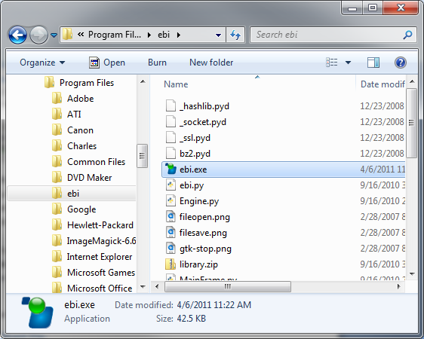

Figure 2. The EBI installed in Microsoft Windows

To start the EBI double-click the file ebi.exe file. It may only appear as “ebi” if you have file extensions hidden on your computer.

## Macintosh™ Installation and Start Up

Double-click (mount) the disk image ebi.dmg. Drag the ebi package to your **Applications** folder (see Figure 3).

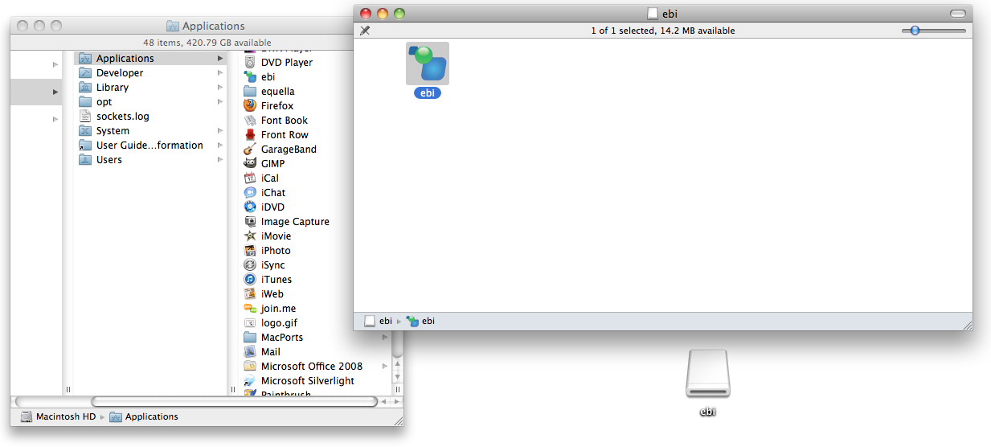

Drag

Figure 3. Installing the EBI on Mac OS X

Start the EBI by launching it from your **Applications** folder.

## Linux Installation and Start Up

To use the EBI on Linux Python 2.7 and wxPython 2.8 must be installed.

1. Install Python 2.7 (http://www.python.org).
2. Install wxPython 2.8 for Python 2.7 (http://wxpython.org)
3. Copy or extract the ebi folder from ebi.zip to a location where you have access to read and write files from.

To start the EBI launch the ebi.py python file with Python.

## Compatibility with Previous EQUELLA Bulk Importer Versions

EBI version 4 is backwards compatible with CSV files used with older versions of the EBI. Settings files (*.ebi) used with versions 2 and 3 can be used with version 4.

Version 1 “state” files (e.g. state.txt) are only compatible with EBI version 1.

## Upgrading to the Latest Version

After installing the EBI you can regularly check what version you are using and if there are any new versions available on the download site. Click the **About** button  on the toolbar. The **About** screen will tell you what version you are using, what the latest available version is and where you can download it from. Upgrading the EBI is a simple matter of replacing the ebi folder or package with the newer version.

# Quick Start Guide

Use the following steps to do a basic import of files into EQUELLA, one file per EQUELLA item.

1. Create a folder on your computer and put the files in it that you wish to upload to EQUELLA.
2. Using Microsoft Excel® create a CSV file in that folder called content.csv.

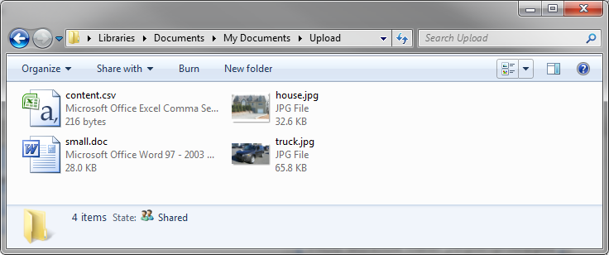

Figure 4. Set up a folder with content.csv and the files you wish to upload

1. In the EQUELLA Admin Console lookup the **metadata targets** (XPaths) of the controls in your EQUELLA collection that map to item name, item description and attachments.

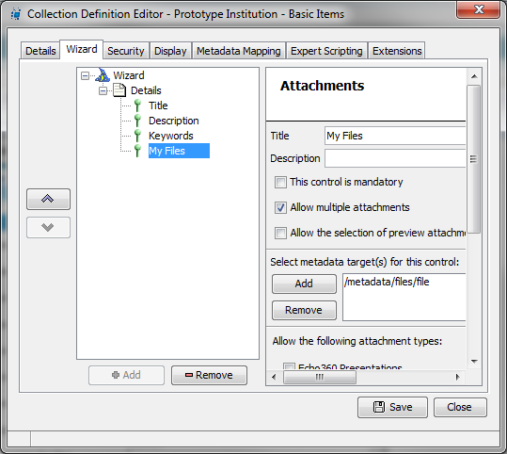Edit the contents of content.csv so that the first row contains the XPaths determined above *omitting the leading slashes* (see Figure 5 below). Note that your XPaths and control titles will likely be different to the example below.

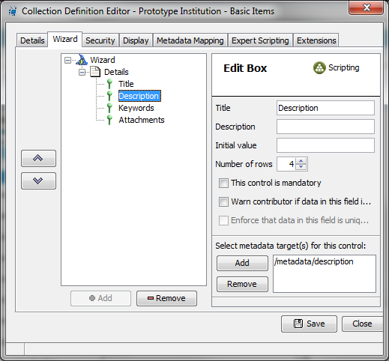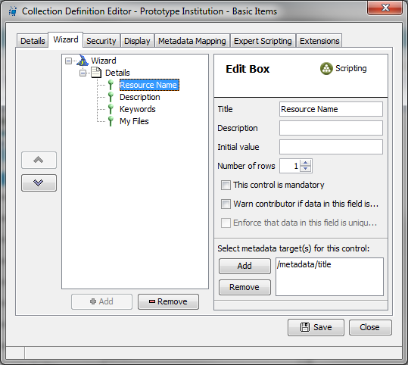

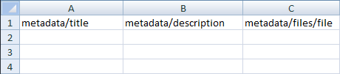

Figure 5. Add the XPaths (leading slashes omitted) of the name, description and attachments fields to the first row of the CSV

1. Add a row for each file you wish to upload and put the item title, description and filename on each row:

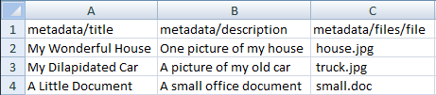

1. In the EBI on the **Connection** tab do the following steps (see Figure 6):
   1. Put your EQUELLA URL in **Institution URL** andfill in **Username** and **Password**
   2. Click **Test/Get Collections**
   3. Select the collection you would like to upload your files to in the **Collection** drop-down

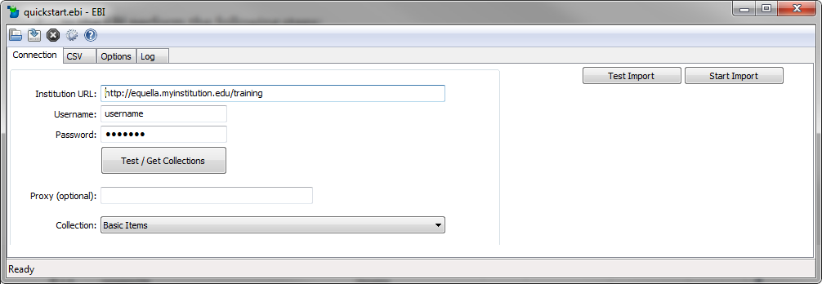

Step c

Step b

Step a

Figure 6. Connection settings in the EBI

1. On the **CSV** tab do the following steps (see Figure 7):
2. Click the **Browse** button, browse to content.csv and select it
3. Under **Column Data Type** double-click on **“Metadata”** on the third row and change it to **“Attachment Locations”**

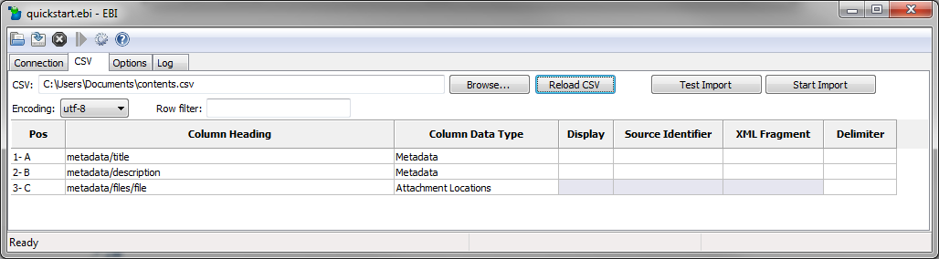

Step e

Step 7

Step d

Figure 7. CSV settings in the EBI

1. Click **Start Import**.Once processing is complete check in the log that you received successes (see Figure 8).

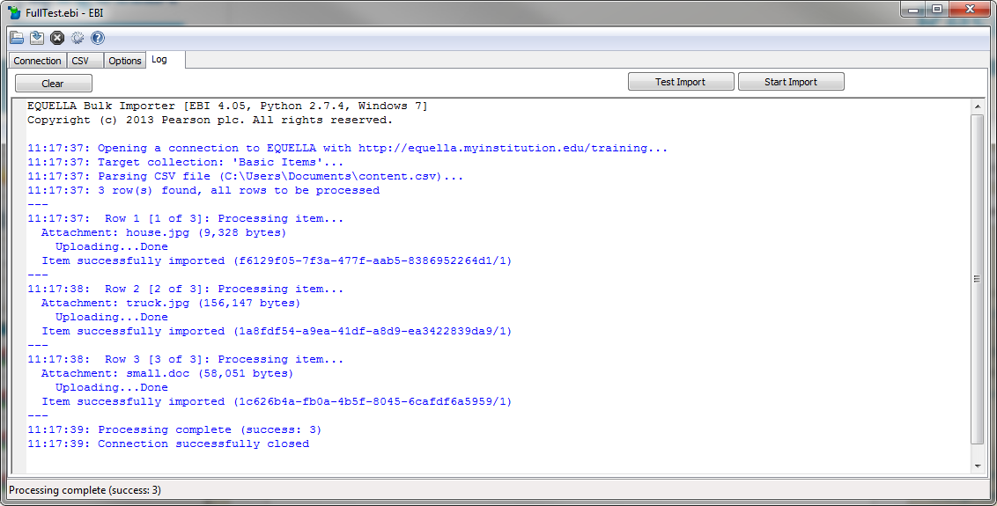

Figure 8. Resulting log

1. Check that the items are created in EQUELLA. There should be one brand new item for each row in content.csv (see Figure 9).

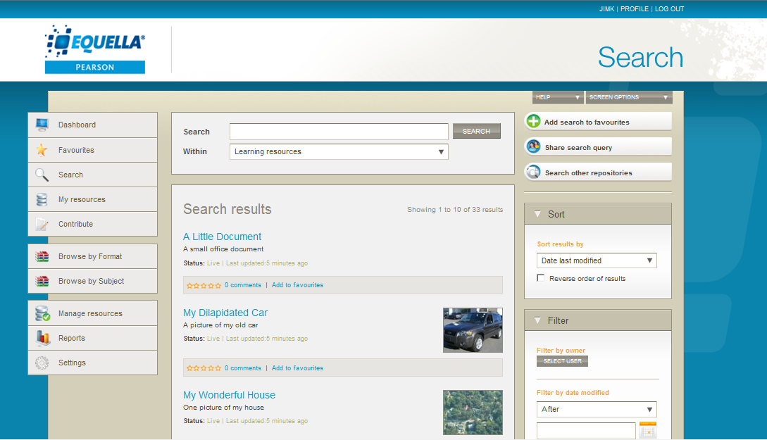

Figure 9. Files successfully uploaded to EQUELLA

# Basic Settings

## Connections Tab

Upon starting the EBI the main form with the **Connections** tab will appear as follows:

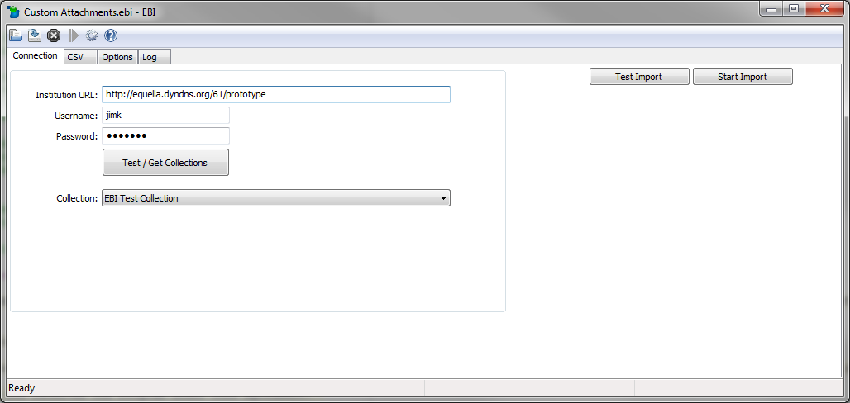

Figure 10. The EBI’s Connection tab

The **Connections** tab and **CSV** tab collect the necessary settings for connecting to EQUELLA and loading the CSV file that provides metadata and location of attachments.

The **Connections** tab has the following fields:

|  |  |  |
| --- | --- | --- |
| **Field** | **Required/ Optional** | **Description** |
| **Institution URL** | Required | The URL of the EQUELLA institution in this field. This will be the URL of your EQUELLA login page (e.g. http://equella.institute.edu/training). |
| **Username** | Required | A username of an EQUELLA user account that has privileges to create items in the collection you specified above (see section 6.5, , page 54). |
| **Password** | Required | The password of the account specified above. |
| **Collection** | Required | An EQUELLA institution can support multiple “collections”. In this field you will need to select which collection you would like to upload content into. |

The following command buttons are available on the **Connections** tab:

|  |  |
| --- | --- |
| **Command Button** | **Function** |
| Test / Get Collections | This button connects to EQUELLA and populates the Collection drop down list with a list of collections the specified EQUELLA user can contribute to. |
| Test Import | This button starts a test run of the import process (see section , *,* page 55). This button appears on every tab. |
| Start Import | This button starts the import process (see section 6, , page 40). This button appears on every tab. |

After filling in the necessary fields on the **Connections** tab the next steps are to prepare a CSV file with metadata and attachment information and load it using the **CSV** tab (see section 4.2, , page 15).

## CSV Tab

The **CSV** tab allows you to load a CSV into the EBI and specify how it should be parsed.

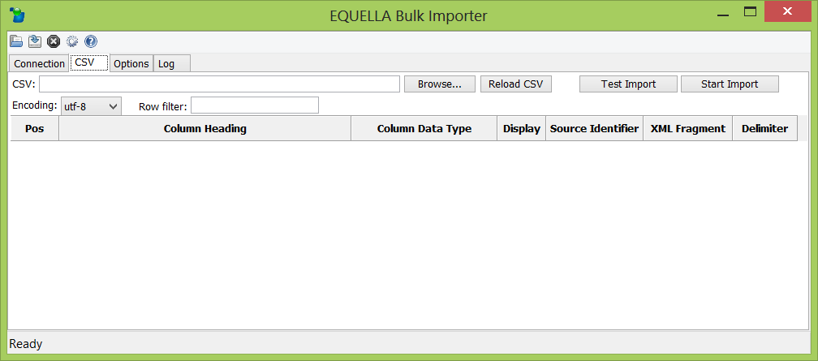

Figure 11. The EBI’s CSV tab

The **CSV** tab has the following fields:

|  |  |  |
| --- | --- | --- |
| **Field** | **Required/ Optional** | **Description** |
| **CSV** | Required | The file path to a CSV of metadata and attachment locations. See section , , page 17) for further information about the CSV. |
| **Encoding** | Required | This field allows you to restrict which rows in your CSV are processed. See section 5.1.5, , page 22) for further information. |
| **Row Filter** | Optional | This field allows you to restrict which rows in your CSV are processed. See section ,, page 57) for further information. |

The following command buttons are available on the **CSV** tab:

|  |  |
| --- | --- |
| **Command Button** | **Function** |
| Browse… | This button allows you to browse your computer and select the CSV file that provides the metadata for the source content. |
| Reload CSV | This button reloads the specified CSV into the EBI. It is useful if you are making changes to the CSV whilst using the EBI. |
| Test Import | This button starts a test run of the import process (see section , *, page* 55). This button appears on every tab. |
| Start Import | This button starts the import process (see section 6, , page 40). This button appears on every tab. |

The requirements for the CSV file are provided in section 5, , page 17). Instructions on how to run the EBI is provided in section 6, , page 52).

## Options Tab

Further settings for advanced configuration are available on the **Options** tab. These settings are referenced in this document as they apply.

## Log Tab

The **Log** tab has a rolling log of messages that display progress and status when you use the EBI to import (or export) content. This tab has a **Clear** button which clear’s the log and **Test Import** and **Start Import** buttons as with the other tabs.

For information about the log see section 6, , page 40.

## Toolbar

The following toolbar buttons are available:

|  |  |  |
| --- | --- | --- |
| **Toolbar Button** | **Description** | **Function** |
| fileopen.png | Open | Loads settings from a settings file (see section 6.11 , page 63). |
| filesave.png | Save | Saves current settings (see section 6.11 , page 63). |
| gtk-stop.png | Stop | Stop processing part way through an upload run (see section , page 53). |
| pause.png | Pause/Unpause | Pauses and unpauses processing part way through an upload run (see section , page 53). |
| options.png | Preferences | Opens the Preferences dialog (see section 6.12, , page 63). |
| gtk-help.png | About | Opens the About dialog to see the current version number, what the latest version available is, where to get the latest version and license information. |

# CSV File Format

To import content into EQUELLA using the EBI a Comma Separated View (CSV) file of a particular format must be provided by you. A CSV is a text file with the extension “.csv” and contains multiple rows of data where the values in each row are separated by commas. CSVs are much like *tables* of data. They can easily be created, viewed and edited in spreadsheet software such as Microsoft® Excel. Below is an example of a simple CSV file designed for the EBI as it appears in Microsoft® Excel:

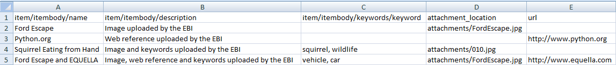

Figure 12. An example CSV file for use with the EBI (viewed in Microsoft® Excel)

## Metadata

### Specifying Metadata to Import

The CSV should contain a row per EQUELLA item to be created in EQUELLA (an “item” is effectively a single record in EQUELLA). The first row should be column headings where each heading is a schema field in EQUELLA. In the example in Figure 12 the first two columns map metadata to the schema fields **metadata/title** and **metadata/description** respectively which appear as follows in the EQUELLA Schema Editor:

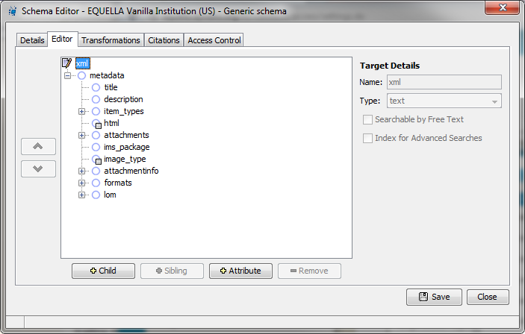

Figure 13. EQUELLA Schema fields that correspond to the first two columns of the example CSV in Figure 12.

As you can see the metadata column headings should not simply be name of the node the content should be mapped to (i.e. “name” and “description”) but the entire *path to the node*. These paths to schema nodes are called **XPaths**.

Though the full XPath to fields in EQUELLA technically always start with **/xml/**, for the EBI you must leave this off the path in your column headings:

Use this:

**metadata/lom/general/keyword**

instead of this:

**/xml/metadata/lom/general/keyword**

The schema of your EQUELLA server that you are importing into will most likely be completely different to the example above. You will need to look at your EQUELLA schema and carefully type in corresponding XPaths as your CSV column headings. It is unlikely you will need a column for every field in your schema as it is likely that many fields will be optional. You may need to discuss with your EQUELLA administrator which schema fields you need to include. For example, the schema in Figure 13 actually has dozens and dozens of fields but the example CSV of Figure 12 only maps to two of these fields and thus the remaining fields are left empty for newly imported records.

Use the **Browse** button on the EBI to select your CSV. Upon doing this it will read the CSV and display the column headings in the columns grid. Figure 14 is an example of the CSV from Figure 12 loaded into the EBI.

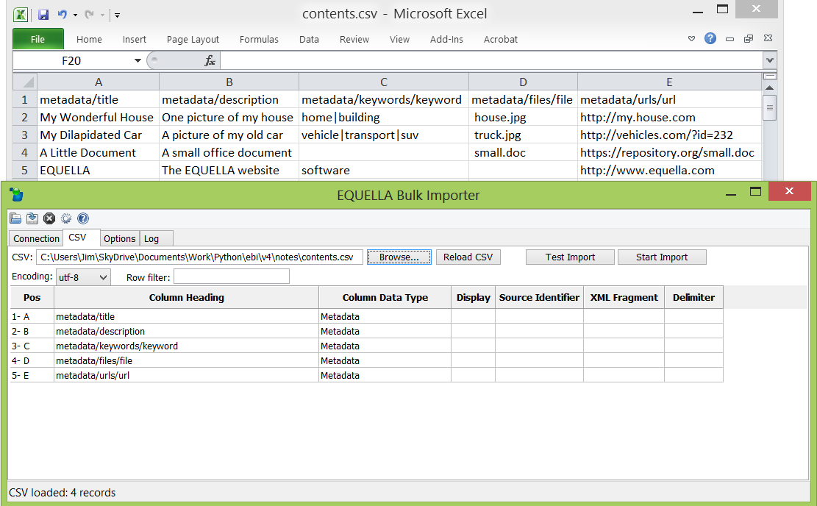

Figure 14. CSV loaded into the EBI

The **Column Data Type** column in the grid defaults to “Metadata” for every CSV column indicating that each column of the CSV will be imported as metadata created in an XML element at an XPath equal to the column heading. Column data types can be changed by double clicking on each one.

If after having loaded it you make any changes to the column headings in your CSV click the **Reload CSV** button to update the grid. The EBI will warn you that it has detected changes in the CSV columns (see Figure 15).

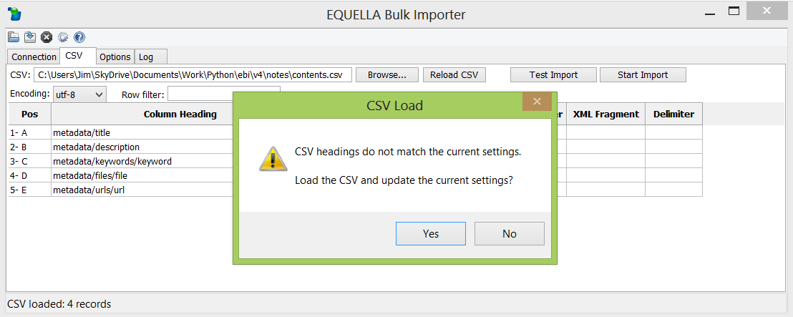

Figure 15. Warning when CSV columns are different to the column headings in the EBI.

Click **“Yes”** and the EBI will update the settings to the new CSV columns.

### Handling Commas in Metadata

Some of your data may contain commas as content. Because a CSV uses commas to delimit from one field to the next in a row this causes ambiguity as to where a field starts and finishes. To solve this, the EBI relies on quotation marks (") to encompass any fields that contain commas in their content. For example:

metadata/title, metadata/description  
 Our House, "This is a picture of my house, my lawn, my cat and my dog"  
 Our Car, This is a picture of my car

In the example above the /metadata/description value of the first record is in quotation marks to prevent the EBI from mistakenly using the commas in the description to determine the end of the field. The surrounding quotation marks are stripped from the content by the EBI prior to import so they won’t appear in your item’s metadata in EQUELLA.

Tools like Microsoft® Excel make it very easy to surround your content with quotation marks where needed. Microsoft® Excel automatically places quotation marks around any text in CSVs that contain commas. Simply use Microsoft® Excel’s “**Save As…**” command and set “**Save as Type**” to “**CSV (Comma delimited)(*.csv)**”.

### Importing Metadata Attributes

EQUELLA supports metadata attributes in its metadata schemas. These can be added to an EQUELLA schema using the EQUELLA schema editor as shown in Figure 16.

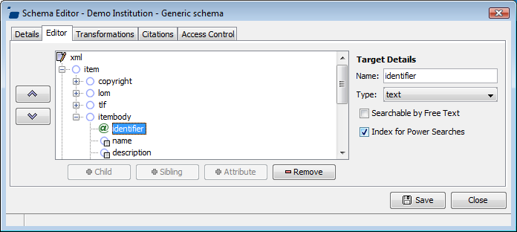

Figure 16. An example of a metadata attribute in EQUELLA

To import values into a schema attribute field specify in the CSV the attribute as you would a usual tag-based field and prefix the attribute name with a “@” character.

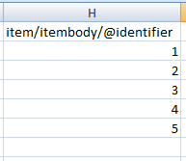

Figure 17. Specifying a column of values in the CSV to import into attribute field in EQUELLA

### Specifying Multi-Value Metadata Fields

EQUELLA supports repeating metadata values. An example of this is in Figure 18 below where the EQUELLA item has two distinct values in the Keywords metadata field.

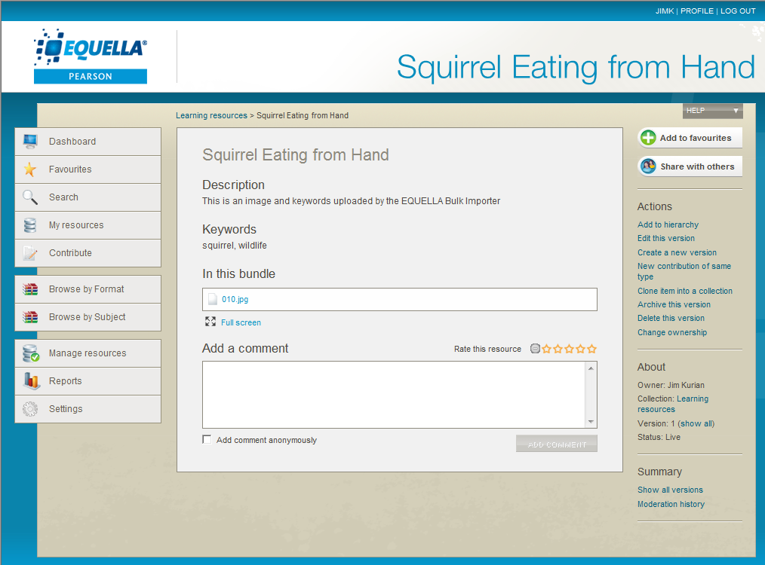

Figure 18. Repeating metadata fields in EQUELLA

It is possible with the EBI to import multiple values per CSV field as repeating fields in EQUELLA. This can be achieved with either delimited values in the one cell or spreading the values across multiple columns of the same XPath column heading (or a combination of both).

#### Using Delimiters to Specify Multi-Value Metadata Fields

You can delimit (i.e. separate) the values in the one field with a special character or string of your choice. In the example in Figure 19 below a pipe character (“**|**”) is used to separate the values in the metadata/keywords/keyword column.

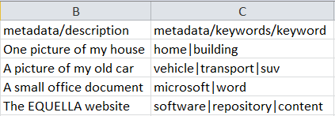

Figure 19. An example of delimiting multi-value fields with special characters

In the **Delimiter** setting in the EBI’s main form specify what delimiters, if any, apply to each column. Figure below shows how our example would be configured for the metadata/keywords/keyword field (see Figure 20).

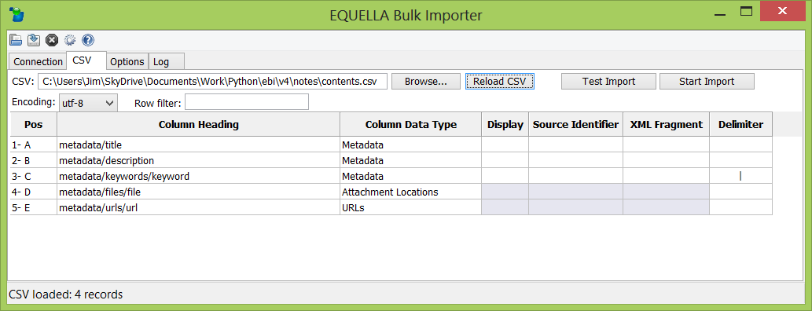

Figure 20. Specifying the delimiting strings for columns that are multi-value

Note that XML does not allow metadata attributes to be repeated. If a multi-value column of attributes is specified in the CSV only the first value will be imported.

NOTE: When viewing multi-value metadata in an EQUELLA wizard bear in mind that only wizard controls that support multiple values (e.g. a shuffle list control) can display all the values. Edit box controls will only display the first value of a repeating metadata field. Also note that multi-value wizard controls that utilize control lists (e.g. check box group, radio button group) will only display values that match values included in the control’s control list.

#### Using Multiple Columns to Specify Multi-Value Metadata Fields

Instead of (or as well as) using delimiters, you can put values of the one metadata element into separate columns by using the *same XPath column heading* across multiple columns (see Figure 31). The EBI will collect the value from each column and add them all as repeating values in the item’s metadata.

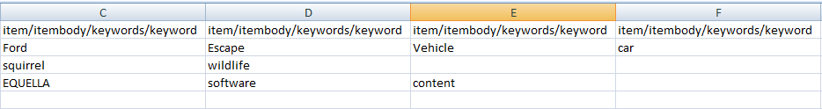

Figure 21. An example of using multiple columns for a multi-value field

Notice that all columns have the same XPath column headings. You can combine delimiting multiple values within the cells (as described in section 5.2.4.1*,* , page 28) as well as specifying multiple columns of the same XPath column heading.

### Special Characters and File Encoding

The EBI supports metadata with special characters such as **©**, **“**, **”**, **¥** and **è**. CSVs that contain such special characters are saved by your computer in a special standard format, or “encoding”, called **unicode**. There is more than one form of unicode and unfortunately there is no guaranteed way to automatically detect what form of unicode a file may be. The EBI supports two types of unicode encoding, UTF-8 and Latin-1, and it requires you to specify which one applies to your CSV file. The encoding can be specified in the **Encoding** field on the **CSV** tab:

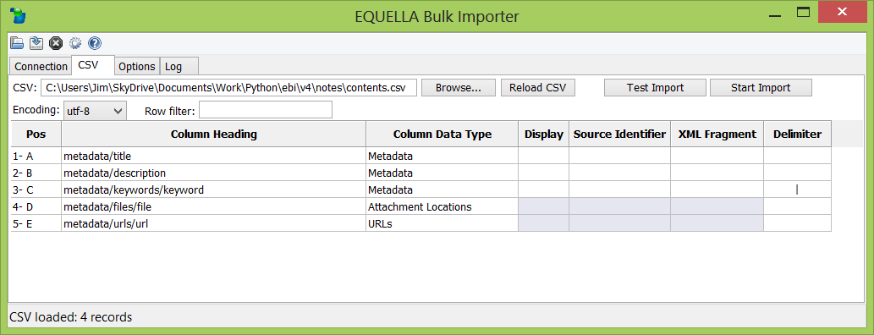

Figure 22. Indicating to the EBI the encoding of your CSV file

The EBI defaults to UTF-8 which is the most common format for text files. However, Microsoft Excel® often uses Latin-1 encoding when creating text files that contain special characters. Upon an import if you receive an error such as 'utf8' codec can't decode byte or special characters appear incorrectly in EQUELLA then try changing the encoding selection and re-run the import.

## Attachments and Hyperlinks

### Specifying Attachments to Import

In the example CSV in Figure 12 the fourth column specifies the location of an attachment for each record. These are file paths and can either be relative to the folder that the CSV is in (e.g. “attachments/FordEscape.jpg”) or absolute (e.g. “c:/My Documents/My Pictures/FordEscape.jpg”). This column can be placed in any position in your CSV. If you are running the EBI on Linux, Unix or Macintosh you should always use forward slashes (“/”) in your file paths. On Windows you can use either forward or backward slashes.

The EBI needs to be instructed which column contains attachments locations. This is done by setting the **Column Data Type** for the corresponding **Column Heading** to “Attachment Locations” (see Figure 23).

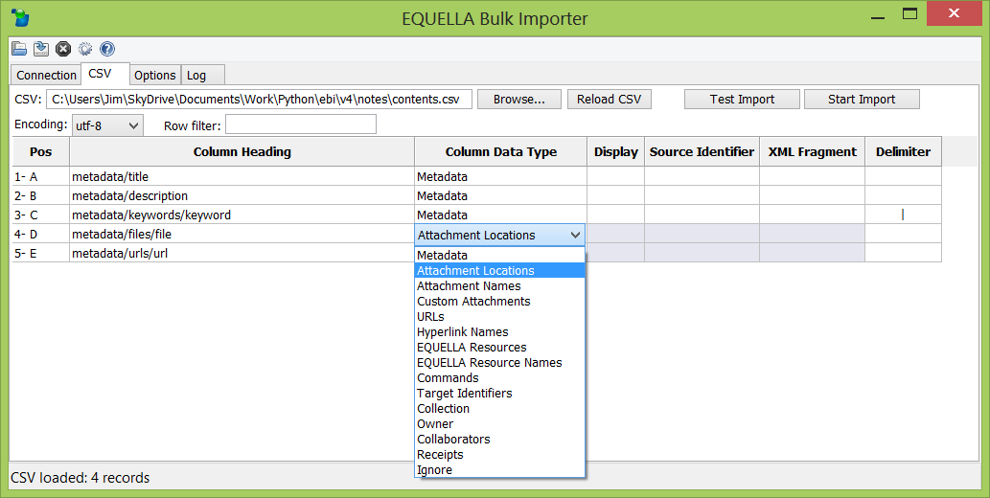

Figure 23. Specify which column in the CSV contains the file names and file paths of attachments

The column heading should be an XPath the same as the metadata target of the EQUELLA wizard Attachments control that manages the attachments being uploaded. If metadata targets are not required (e.g. when using EQUELLA 4.1) then either leave the column heading blank or prefix the column heading with # (e.g. “#attachments”).

Running the import process will create an item per row each with its specified attachment. How to run an import is described in detail in section 5.3.4, , page 40). The example below was created from an import of the first record in the example CSV in Figure 12 (the second row in the CSV):

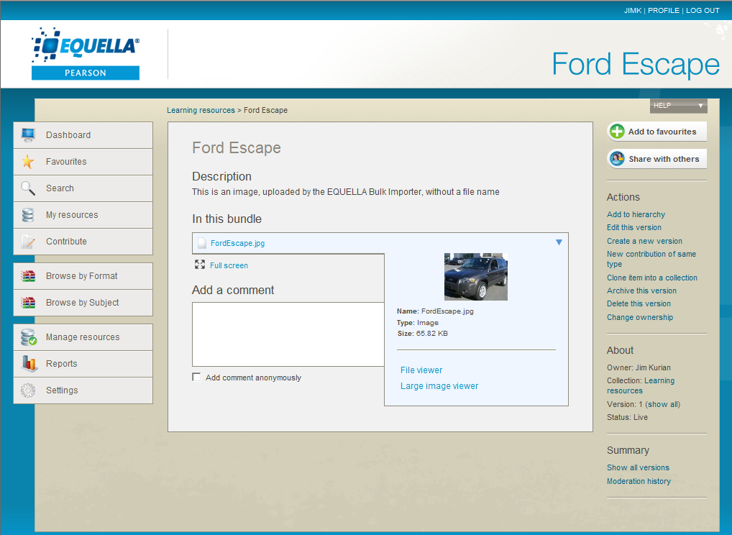

Figure 24. An item with an attachment created in EQUELLA by the EBI

#### Changing the Base Path of Attachment Locations

Relative paths in Attachment Locations are by default relative to the folder the CSV file is in. You can, however, specify a different “base path” for Attachment Locations to be relative to by changing thefield **Use following base path for attachments** on the **Options** tab. 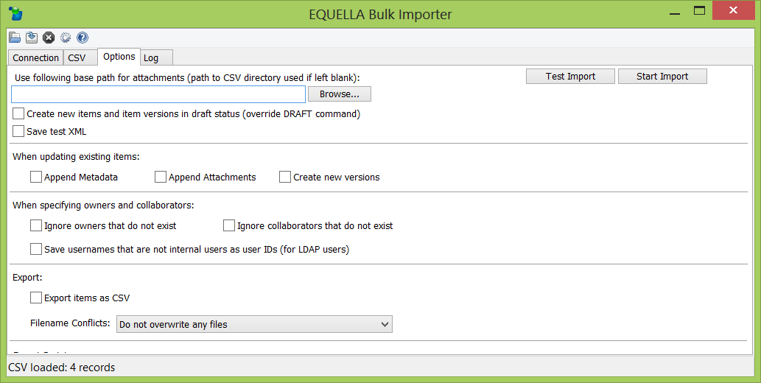

Figure 25. Specifying a base path for Attachment Locations

For example, you might specify in this field an attachments base path of /Users/jimk/Documents and then in a row in your CSV an Attachment Location of attachments/myimage.jpg. When run, the EBI would attach the file found at /Users/jimk/Documents/attachments/myimage.jpg.

### Specifying URLs to Import

The previous example showed how to attach a file such as an image or a document. You can also upload references to other web pages. In the example in Figure 3 the fifth column is exactly that. The URLs must include the “http://” or “https://” text on the front of them (e.g. “http://www.python.org” not “www.python.org”).

As with file attachments, the column heading for this column should be the metadata target of the EQUELLA wizard Attachments control that manages the URLs. If metadata targets are not required (e.g. when using EQUELLA 4.1 or earlier) then either leave the column heading blank or prefix the column heading with # (e.g. “#urls”).

To allow the EBI to identify which column has URLs in it specify a **Column Data Type** of “**URLs**” for the corresponding column in the columns grid (see Figure 26).

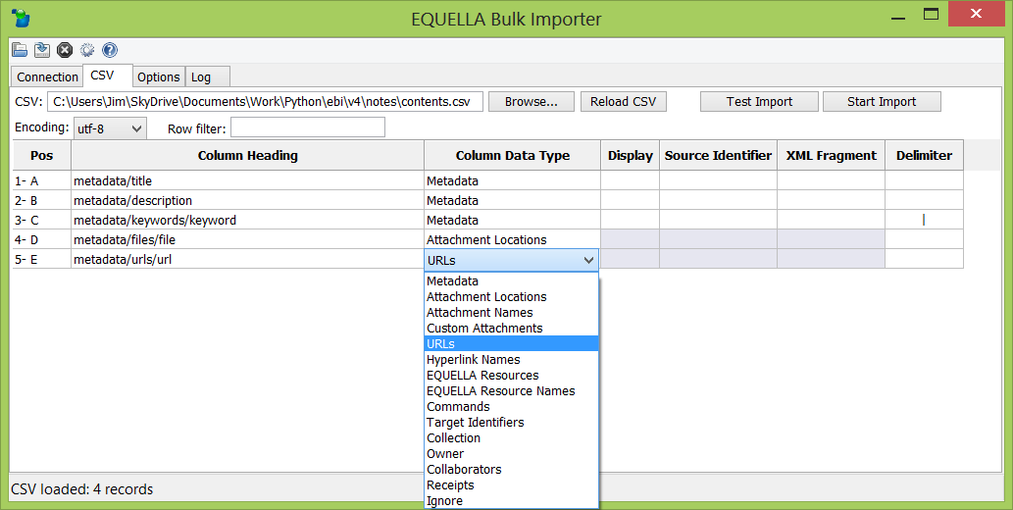

Figure 26. Specify which column in the CSV contains URLs

### Specifying Link Names for Attachments and URLs

The fifth and seventh columns in the CSV example in Figure 27 below demonstrate how to optionally provide names for links to the attachments or names for the URLs.

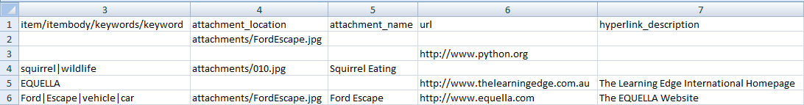

Figure 27. Specifying link names for attachments and URLs in the CSV

The last record in Figure 27 appears in EQUELLA as shown in the example below (note that this is an example of a single item in EQUELLA with bothan attachment *and* a URL):

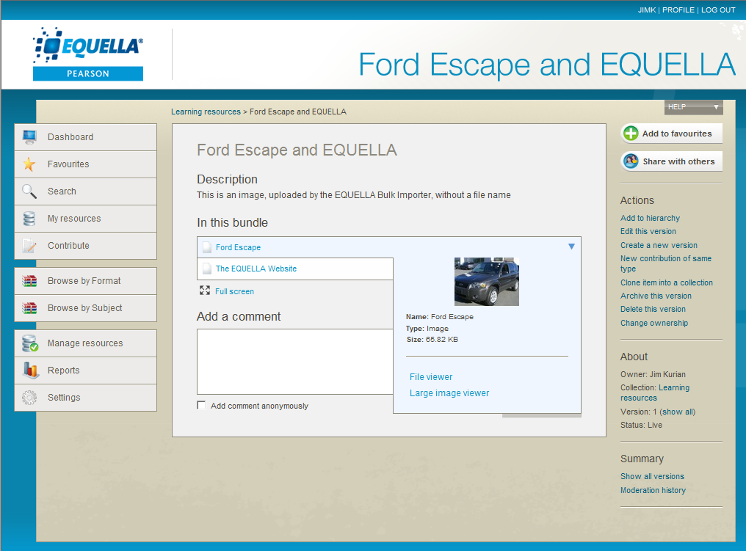

Figure 28. Link names for attachments and URLs displayed in EQUELLA

As with URLs and attachments paths, these columns can be positioned anywhere in the CSV. They must be identified in the EBI’s main form as “**Attachment Names**” and “**Hyperlink Names**” for their **Column Data Types**. You can provide and column heading you like or leave it blank as the EBI does not use the column headings of Attachment Names and Hyperlink Names. Providing values in these columns is optional for each row. If you leave some cells blank in the columns then the EBI will use the filename or url as the link name.

Note: the maximum length allowable in EQUELLA for an attachment or hyperlink description is 1,024 characters.

### Specifying Multiple Attachments and Hyperlinks per Item

EQUELLA supports multiple attachments and hyperlinks per item as shown in Figure 29 below.

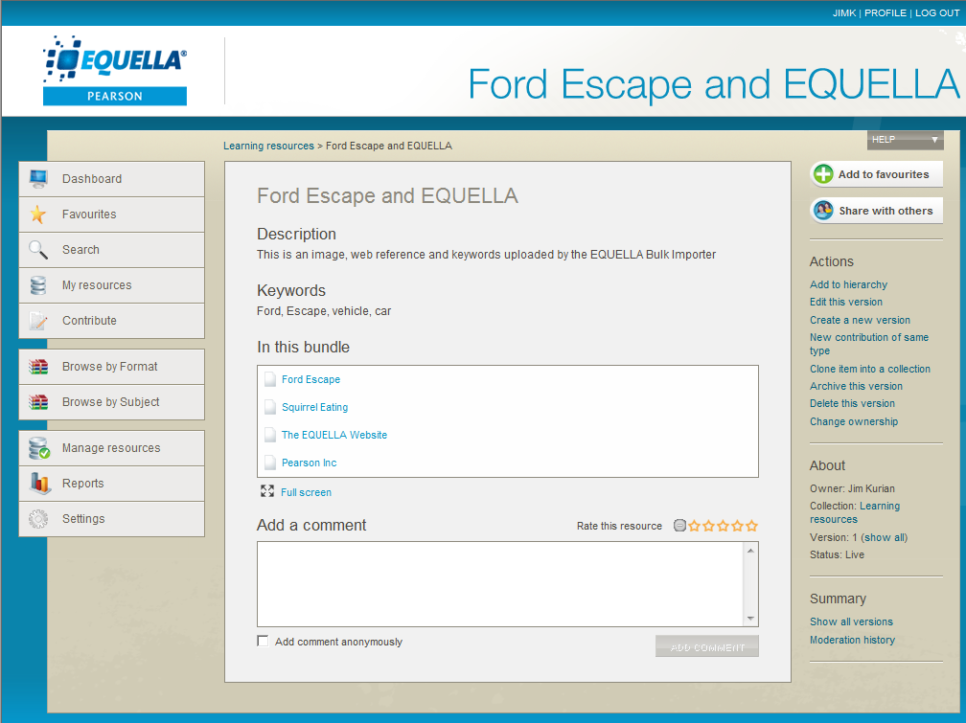

Figure 29. Multiple attachments and hyperlinks in the one EQUELLA item

This can be specified in the CSV for the EBI in much the same way as multi-value metadata fields (see section 5.1.4, , page 20), either with delimiters or multiple columns.

#### Using Delimiters to Specify Multiple Attachments

As with multi-value metadata fields, separate the attachment paths, attachment names, hyperlink urls and hyperlink names with a delimiting string of your choice (e.g. a pipe character (“**|**”).

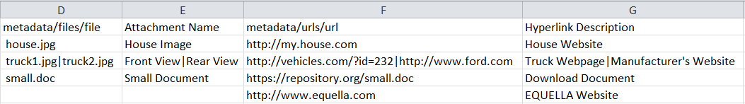

Figure 30. Delimiting attachment paths, attachment names, hyperlink urls and hyperlink names with a special character

Specify the delimiting string in the **Delimiter** setting for the corresponding columns in the EBI’s main form (see Figure 31).

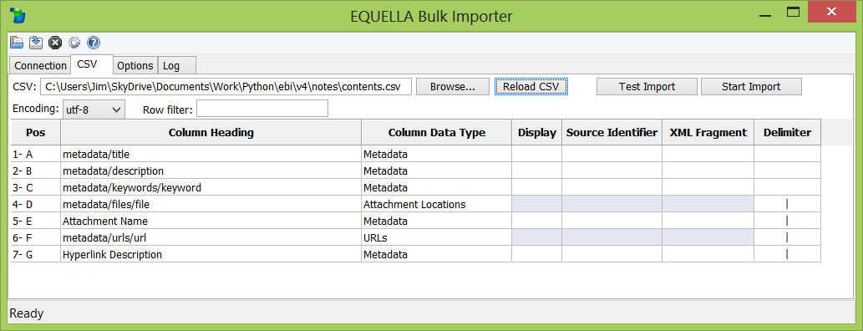

Figure 31. Specifying the delimiting strings for attachment paths, attachment names, hyperlink urls and hyperlink names

#### Using Multiple Columns to Specify Multiple Attachments

As with multi-value metadata fields, you can specify multiple columns each with a **Column Data Type** of Attachment Location (see Figure 32) to attach multiple attachments to a single item.

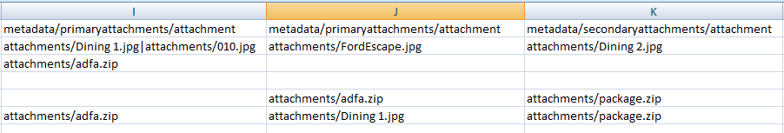

Figure 32. Specifying the multiple Attachment Location column

Note that the first two columns in the example above use the same XPath column heading and the third column has a different XPath column heading. In EQUELLA 5.0 and higher this would result in the attachments from the first two column able to be managed with the one Attachments Control (that uses a metadata target of /metadata/primaryattachments/attachment) and attachments from the third column could be managed by another Attachments control (that uses a metadata target of /metadata/secondaryattachments/attachment).

Also note that the first column includes a value with a pipe delimiter. As you can see it is possible to use combination of delimiters and multiple columns when specifying multiple attachments.

#### Specifying Link Names for Multiple Attachments and Hyperlinks

Specifying Link and Attachment names for columns of Column Data Type of **Attachment Location** or **URL** is done by including columns of Column Data Type of **Attachment Name** and/or **Hyperlink Name** in the same order (read from left to right in the CSV) as the **Attachment Location** columns and **URLs** columns appear (see Figure 33).

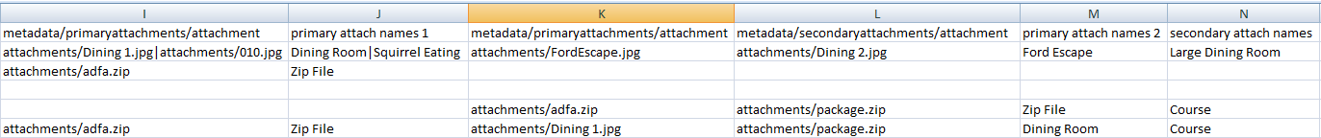

Figure 33. Specifying attachment names for columns of Attachment Locations and URLs

The red lines in the example above show how the EBI will match up the columns of Attachment Locations with Attachment Names. For example, the Attachment Locations column at L (“metadata/secondaryattachments/attachment”) will be paired up with Attachment Names column at N (“secondary attach names”) because they are *both the third* occurrence (counted from the left) in the CSV of an Attachment Locations and Attachment Names columns respectively.

Where delimiters are used, the EBI matches pairs of attachment path and attachment name in each item by matching their corresponding position in the cell. For example, in the first item in the CSV in Figure 33 above the attachment attachments/010.jpg (in column I) will have the corresponding attachment name of “Squirrel Eating” (in column J) applied to it in EQUELLA as *both values are second* in their list of values in their respective delimited lists. Matching of hyperlink urls and hyperlink names are determined in the same way.

## Advanced Content

### Appending XML Fragments to Metadata

Using the EBI it is possible to append a fragment of an XML document to a node. For example, we may wish to append the following XML metadata to an element called metadata/contributors as in Figure 34.

<contributor>

<name>**Sue Daley**</name>  
 <roles>

<role>**Author**</role>  
 <role>**Illustrator**</role>

</roles>

</contributor>

<contributor>

<name>**Bobby Andrews**</name>  
 <roles>

<role>**Editor**</role>  
 </roles>

</contributor>

Figure 34. Example of an XML fragment

This can be done by placing the required XML fragment in the cell as text:

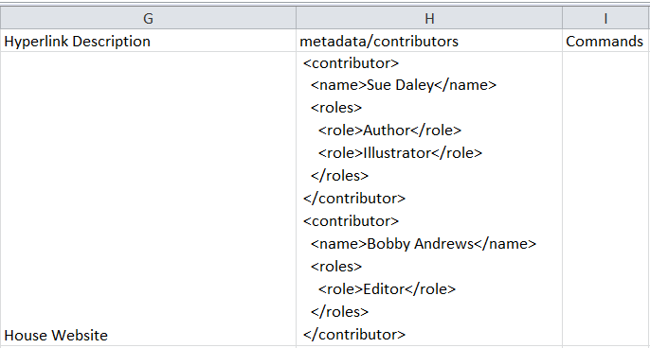

Figure 35. Specifying an XML fragment as metadata

Note that the xml does not need to be well-formed meaning that it can have more than one root node. For the example above the fragment contains two contributor root nodes. This is usually unacceptable as a well-formed XML document but is acceptable here as an XML fragment. Note though that the XML fragment must be *free-standing* meaning that every tag must be properly closed.

Text in XML nodes cannot include ampersands (“&”), less-than (“<”) or greater-than (“>”) characters. If such characters are needed inside a node then the following strings should be used instead:

|  |  |
| --- | --- |
| **Character** | **Escape Sequence** |
| & | &amp; |
| < | &lt; |
| > | &gt; |

In the **XML Fragment** setting in the EBI’s main form specify each column that contains XML fragments (see Figure 36).

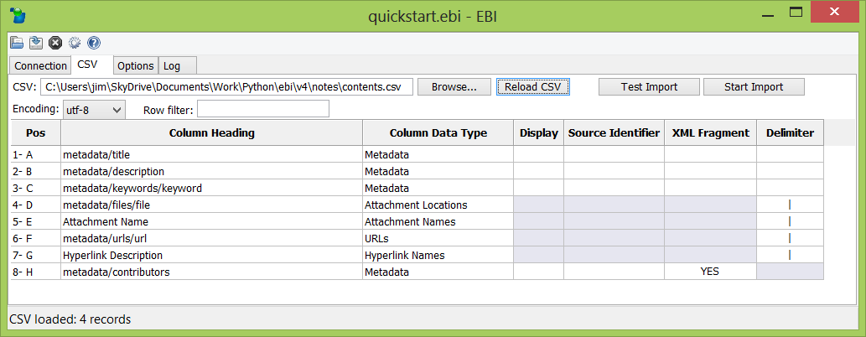

Figure 36. Specify which columns contain XML fragments

Note that the EBI builds the metadata for the item by reading the CSV from left to right. For this reason, an XML fragment that encompasses other metadata fields specified in the same row should be positioned *before* the other encompassed metadata fields in the column order of the CSV. Otherwise they will be overwritten by the encompassing XML fragment.

### Repeating Sub-trees and XPath Support

The EBI supports a subset of XPath 1.0 and 2.0. The full reference is provided in section 7.5 , page 90.

At times you may wish to form repeating sub-trees in your XML. This is the type of metadata that is commonly created in EQUELLA wizards with a Repeater control. You may also wish to associate attachments or additional metadata (such as attributes) to these sub-trees.

Sub-trees can be achieved with XML Fragments (see section 5.3.1 , page 30) and attachments can be associated with sub-trees by using Custom Attachments (see section 5.3.8 , page 46). These features are designed to produce very complex or inter-related XML. However, producing the CSV data that these features rely on can be challenging.

If your need is only to form simple sub-trees or relate individual elements or attachments with simple sub-trees then an alternative, and often simpler, approach is to use **XPath indexes**. An example of an XPath with an index is as follows:

metadata/contributors/contributor[2]/name

This example is referencing the name child element of the second instance of a repeating sub-tree called contributor.

Among other things, you can create simple repeating sub-trees from columns of data by referencing the repeating elements by their index. Following are some practical examples of using XPath indexes with the EBI.

#### Example 1: Forming Simple Sub-trees from CSV Columns

Suppose you wish to construct the following repeating sub-tree in your item XML.

<contributors>  
 <contributor>  
 <name>Sam Doe</name>  
 <role>Author</role>  
 </contributor>  
 <contributor>  
 <name>Lee Phillips</name>  
 <role>Editor</role>  
 </contributor>  
</contributors>

Rather than using XML Fragments let’s say you would prefer to specify the names and roles in separate columns in your CSV for simplicity. Using XPath indexes the sub-trees can be formed by using the following CSV setup.



Figure 37. Using XPath indexes to construct simple repeating sub-trees

In the above CSV, when the EBI encounters columns H and I it will first create the contributors element (if it doesn’t already exist). It will then create the contributor, name and role elements for the *first* contributor sub-tree as the XPath contributor element index in columns H and I is [1]. Subsequently, when the EBI encounters columns J and K it will create the contributor, name and role elements for the *second* contributor as the XPath contributor element index in those columns is [2].

For shallow, simple sub-trees using XPath indexes rather than XML Fragments is often the easiest approach. However, if your sub-trees are deeper, more complex and varying then it can be unwieldy to use XPath indexes in which case XML Fragments may be the better option.

#### Example 2: Associating Language Attributes to Textual Elements

EQUELLA supports a multi-language edit box control that allows a contributor to complete a field in multiple languages. The metadata produced by this control requires an attribute for each value indicating what language each element represents. For example:

<metadata>  
 <title>  
 <string language="**en**">Hello!</string>  
 <string language="**fr**">Bonjour!</string>  
 <string language="**de**">Guten tag!</string>  
 </title>  
</metadata>

The above metadata could be produced using XML Fragments. However, a simpler alternative is to use XPath indexes as in Figure 38. This allows the titles to be placed as simple text in separate columns, one for each language.



Figure 38. Using XPath indexes to associate metadata with repeating metadata

Columns J, K and L create repeating values for metadata/title/string. They are created in the order they appear in the CSV from left to right. Columns M, N and O add a “language” attribute to each value. The indexes [1], [2] and [3] instruct the EBI which metadata/title/string element to append each attribute to. The element containing “Bonjour” has an index of 2 because it is the second metadata/title/string element created by the EBI.

Note that the repeating metadata/title/string elements could have just as easily been created using delimiters or XML fragments. However you create the repeating elements, remember to put the columns that create them *before* (i.e. to the left of) the columns that attach child metadata to them (i.e. before columns M, N and O in this example).

#### Example 3: Associating Attachments to Sub-trees

Using XPath indexes it is also possible to associate attachments to repeating metadata. The following example shows how attachments (in this case résumés) are associated with repeating metadata (in this case a sub-tree called a “contributor”).

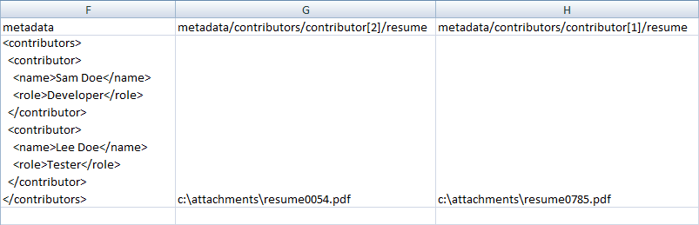

Figure 39. Using XPath indexes to associate attachments with repeating metadata

Columns G and H in the above example should be both set as Attachment Location columns in the EBI. Their XPath column headings have indexes to instruct the EBI which contributor element to add each resume child element to. Each resume child element contains a reference to the corresponding attachment. Figure 40 shoes how the resulting metadata and attachments might appear in a contribution wizard. Note how each “résumé” attachment is associated with a “contributor”.

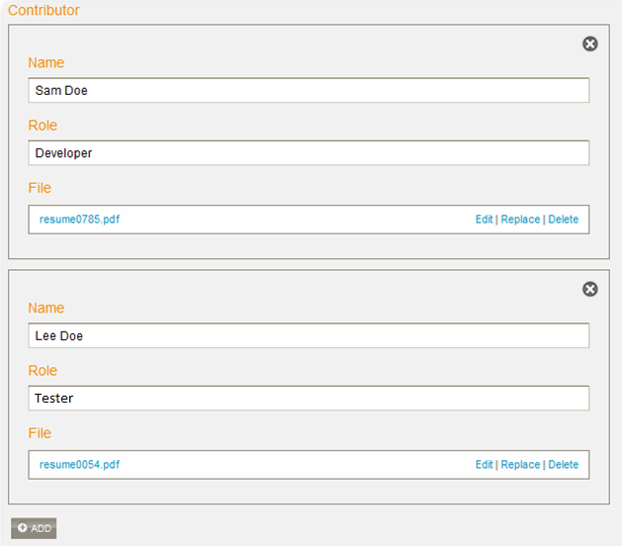

Figure 40. The resulting metadata (viewed in a contribution wizard) from the previous example

### Using Command Options

It is possible to specify additional upload options for each row of your CSV. This can be used to perform advanced actions. This includes managing special types of content such as zip files and IMS/SCORM packages.

To do so, include a column in your CSV for specifying command options for records that they apply to (see Figure 41).

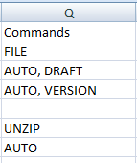

Figure 41. Include a column of command options in your CSV

You can name the heading of this column anything or leave it blank. Specify in the main form the position of your command options column by selecting “**Commands**” in the **Column Data Type** field (see Figure 42).

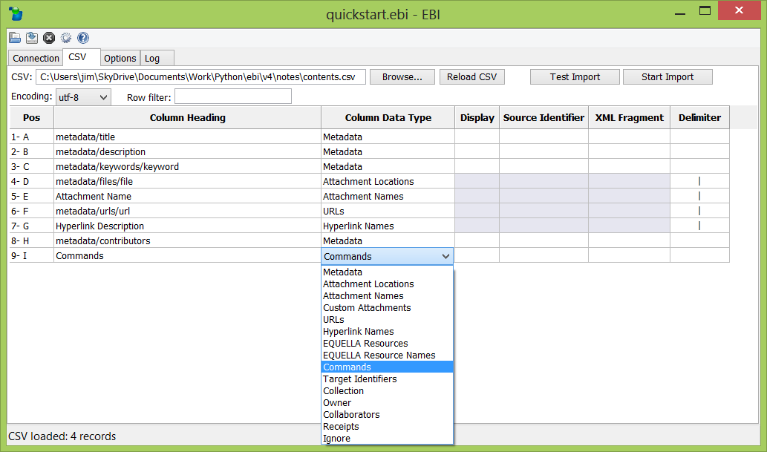

Figure 42. Specify the CSV column for command options in the EBI

Include the desired commands in the commands column for the applicable rows. The supported command options and their effects are provided below. Command options are case insensitive. You can include more than one command per row by separating the multiple commands in the one column with commas.

|  |  |
| --- | --- |
| **Command Option** | **Command Option Effect** |
| **UNZIP** | Attempts to unzip all attachments of the record after uploading them to EQUELLA. If any files are not valid zip files an error will occur and the entire record will be rejected. Note that no links will appear in the item unless a list of links is specified.  See section , page 37 for further information. |
| **IMS** | Uploads the last specified attachment in the record to EQUELLA as an IMS content package or SCORM package. If any attachments are not valid IMS package files an error will occur and the entire record will be rejected. Only the last attachment will be uploaded as EQUELLA supports only one IMS package per item. |
| **AUTO** | Inspects each attachment and automatically upload IMS content packages or SCORM packages as IMS packages, unzip zip files (that are not IMS packages) and simply attach all non-zip files |
| **SCORM** | In some cases SCORM packages are unable to be recognized as anything other than simple IMS packages. Use this command to force EBI to upload the package as a SCORM package. |
| **VERSION** | If updating existing items using source identifiers or target identifiers (see section , page 58) a new version of the item will be created rather than the existing item version being updated.  This can also be achieved using the **Options** tab. See section , page 61) for further information. |
| **DRAFT** | If creating new items or new versions they will be created in DRAFT status. This command is ignored when updating existing items without the VERSION command option (see section , page 58).  This can also be achieved using the **Options** tab. See section 6.10 , page 63 for further information. |
| **REPLACEMETA** | When updating an existing item metadata from the CSV replaces only thatmetadata and leaves all other existing metadata untouched.  This can also be achieved using the **Options** tab. See section , page62 for further information. |
| **APPENDMETA** | When updating an existing item metadata from the CSV is *appended* to the existing item metadata.  This can also be achieved using the **Options** tab. See section , page62 for further information. |
| **APPENDATTACH** | When updating an existing item attachments specified in the CSV are *appended* to the existing item attachments.  This can also be achieved using the **Options** tab. See section , page 62 for further information. |
| **DELETE** | If updating existing items using source identifiers or target identifiers (see section , page 58) the item will be deleted. If using target identifiers an item can be purged by deleting an already deleted item. |
| **CAL_PORTION** | When uploading “portion” items for CAL compliance. See section 5.3.9 , page 48 for further information. |

#### Creating Item Links to Files within a Zip File

If unzipping an attachment using either the “**UNZIP**” command or the “**AUTO**” command you can specify item links to particular files within the zip file. This is done by specifying a list of links to unzipped files in as the attachment name of the zip file. An example of such as list is shown in Figure 43.

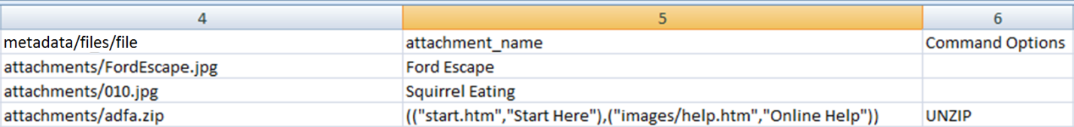

Figure 43. Specifying a list of item attachment links to files within the zip

The CSV example above instructs the EBI to unzip all the files in attachment adfa.zip and adds two hyperlinks in the item called “Start Here” and “Online Help”. The result of the list of links in EQUELLA is shown in Figure 44.

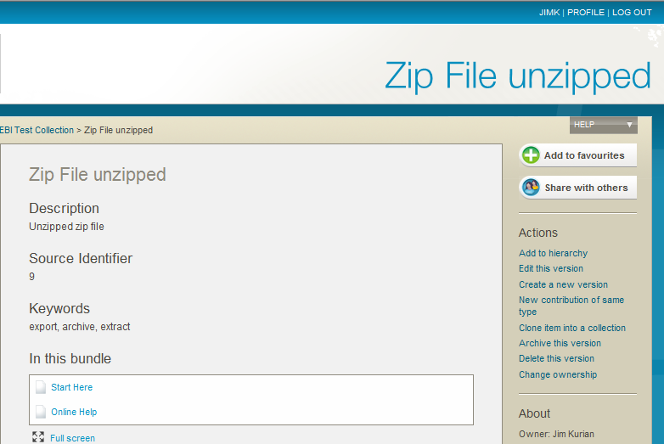

Figure 44. The extracted zip attachments from the third row of the CSV in Figure 43

The item in Figure 44 actually has attachments of all the unzipped files from adfa.zip but only displays links to the two specified files start.htm and images/help.htm.

The list of links should be formatted as follows (without the linefeeds):

(  
 ("<filepath in zip of file 1>", "<description of file 1>"),  
 ("<filepath in zip of file 2>", "<description of file 2>"),  
 ("<filepath in zip of file 3>", "<description of file 3>"),  
 .  
 .  
 ("<filepath in zip of file *n*>", "<description of file *n*>")  
)

The format of the list can be described as a list of pairs where each pair consists of a filepath to a file in the zip (relative to the root of the zip file) and a description (i.e. name for the hyperlink) as it should appear in the item display page.

Note that even a zip file with a single hyperlinked file should be enclosed in two sets of parentheses e.g. if start.htm was the only hyperlinked file then use (("start.htm", "Start Here")) not ("start.htm", "Start Here"). Note the nested parentheses in the correct example.

A shortcut to instruct that *all* files in the zip have hyperlinks created can be specified by using the name pair (("*", "*")). This instructs the EBI to create a hyperlink for *every* file in the zip file using the name of the filename as the hyperlink name. If used in conjunction with named pairs it will name only files that do not have explicitly named pairs. For example, the following list of links will create two named hyperlinks and automatically create filename-based links for the remaining files:

(("start.htm","Start Here"),("images/help.htm","Online Help"),("*","*"))

The outcome of the above list of links is shown in Figure 45.

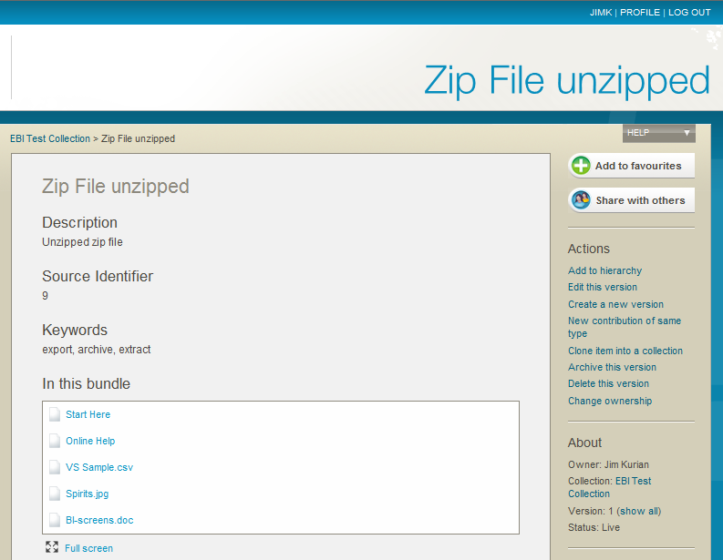

These links are created by the pairs  
**("start.htm","Start Here")** and **("images/help.htm","Online Help")**

These links are created  
by the pair **("*","*")**

Figure 45. The extracted zip attachments from a mix of explicit and wildcard name pairs in a list of links

Specifying a name pair to the zip file itself creates a link to download the zip file. For example:

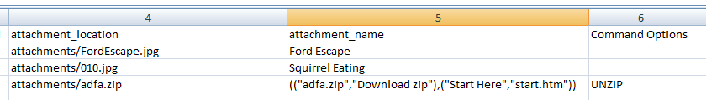

Figure 46. Providing users with a link to the zip file itself

In the example above, along with the unzipped files, a link called “Download zip” will be added to the item that allows users to download the entire zip file (see Figure 47).

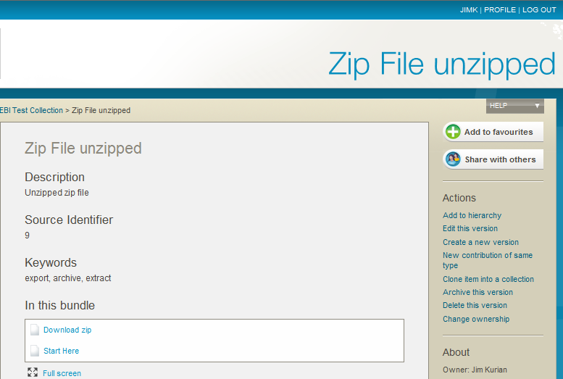

Figure 47. The outcome of specifying a link to the zip file itself (along with a single file)

As with other attachments such as simple files and IMS packages, it is possible to include a mixture of zip files (with lists of links) and other files by using delimiters and the “**AUTO**” command. The “**AUTO**” command will unzip the zip file and treat the other files included in the record appropriately. For example, each record of the CSV in Figure 48 contains a valid list of attachments, each attachments list consisting of a mixture of a zip file (with a list of links) and simple files and IMS packages. See section 5.2.4, , page 27 for more information on specifying multiple attachments in a record.



Figure 48. Mixing attachments with zip files using the AUTO command

### Setting Owners and Collaborators for Items

#### Setting Owners (EQUELLA 5.1 and higher only)

By default the EBI sets the owner of new items and new item versions to the EBI username i.e. the user specified in the main form. You can instead set the owner of each item to a specific EQUELLA user account by adding a column to the CSV with a single username per row. The **Column Data Type** for the column should be set to “Owner” and the column heading can be anything. For any rows where a cell in the owner column is blank the EBI will set the EBI username as the owner.

If a username is specified that is not in EQUELLA the EBI will raise an error and skip the row. Optionally, you can configure the EBI to fall back to using the EBI username when it encounters a non-existent username. Do this by checking **Options** tab **-> Ignore owners that do not exist** checkbox.

#### Setting Collaborators (EQUELLA 5.1 and higher only)

You can add collaborators to an item in much the same was as you can specify owners. Add a column of any heading to your CSV and put in a delimited list of usernames. Set the **Column Data Type** of the column to “Collaborators” and specify what delimiter you are using for the column. Leave the cell blank for any items that should have no collaborators.

As with owners, if a username is specified that is not in EQUELLA the EBI will raise an error and skip the row. Optionally, you can configure the EBI to simply ignore non-existent usernames and create/update the item anyway. Do this by checking **Options** tab **-> Ignore collaborators that do not exist** checkbox.

#### Setting LDAP or Replicated Datastore Users as Owners and Collaborators

When specifying LDAP and replicated datastore users as owners and collaborators instead of usernames use user IDs and set **Options** tab **-> Save usernames that are not internal users as user IDs** checkbox. In some cases the user ID may be the same as the username. Check your LDAP or replicated datastore settings to make certain. See the *EQUELLA LDAP Configuration Guide* for further information.

### Managing Attachment Thumbnails (EQUELLA 6.3 QA1 and higher only)

#### Suppressing and Specifying Thumbnails

By including a column with a **Column Data Type** of “Thumbnails” the EBI will instruct EQUELLA to only generate thumbnails for file attachments whose attachment locations are listed in the Thumbnails column. EQUELLA will be instructed by the EBI to suppress thumbnail generation for any attachment location entries that do not appear in the Thumbnails column.

Three formats can be used to specify Attachment locations in the Thumbnails column:

* Exact attachment location (e.g. Circular Motion 1.jpg, images\Dining 1.jpg)
* File extension wildcard (e.g. *.tif)
* Attachment location with custom thumbnail separated with a colon (e.g. images\squirrel:Dining 1.jpg)

A combination of any of the above formats can be specified by separating the values with a delimiter. Figure 49 is an example CSV that utilizes the “Thumbnails” column data type in all three different ways.

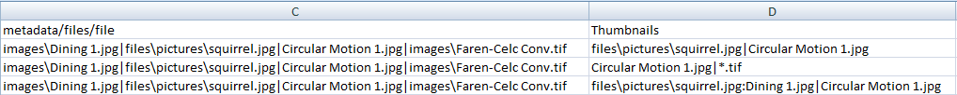

Figure . Suppressing and specifying thumbnail generation

In the example above Column C has been given a column data type of “Attachment Locations” and column D has been given a column data type of “Thumbnails”. Both columns are using “|” as the delimiter. Each of the three data rows have four files specified in the Attachment Locations column. Note that the Thumbnails column’s column heading may be anything as the EBI will ignore it.

In the first data row two attachment locations have been specified in the “Thumbnails” column, files\pictures\squirrel.jpg and Circular Motion 1.jpg. The EBI will instruct EQUELLA to generate thumbnails only for those two attachment locations and suppress thumbnail generation for the rest (images\Dining 1.jpg and images\Faren-Celc Conv.tif). Note that the Attachment Location values are case-sensitive.

In the second data row an extension wildcard *.tif is used in the “Thumbnails” column. This causes EBI to instruct EQUELLA to generate thumbnails of all attachment locations that have that file extension. This is a case *insensitive* match but the extension must be spelt the same e.g. *.jpg will not match *.jpeg.

The third data row demonstrates how to specify a custom thumbnail. In this case the EBI will still instruct EQUELLA to suppress thumbnail generation of the attachment location and will specify another file attachment to use as a thumbnail. In the example, the “Thumbnails” column value files\pictures\squirrel.jpg:Dining 1.jpg instructs the EBI that the attachment location files\pictures\squirrel.jpg should use the file Dining 1.jpg as its thumbnail (which should be a file attached to the same item) and thumbnail generation for files\pictures\squirrel.jpg will be suppressed. Note that the thumbnail should be specified as a *relative* path from the item’s filestore.

#### Selecting the Item’s Thumbnail

In an EQUELLA contribution wizard it is possible to select a thumbnail for the item to control how it is displayed in search results (see Figure 50).

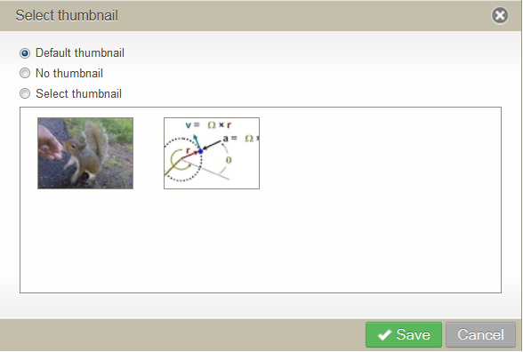

Figure . Selecting an item’s thumbnail in an EQUELLA contribution wizard

This thumbnail selection can be achieved in an EBI import by including a column with a **Column Data Type** of “Selected Thumbnail” (the column can have any column heading).

The allowed values are:

* “DEFAULT” or empty (equivalent)
* “NONE”
* An attachment location
* An extension wildcard

The following example (Figure 51) demonstrates all four ways of specifying a selected thumbnail.

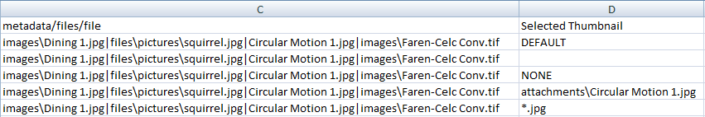

Figure . Specifying an item’s selected thumbnail with the EBI

The selected thumbnail format used in the first two data rows (DEFAULT and empty) both have the same effect which is the same as selecting “Default” for the selected thumbnail in an item’s contribution wizard.

The format used in the third data row (NONE) is an example of the equivalent of selecting “None” for the selected thumbnail in an item’s contribution wizard.

The format used in the fourth data row (attachments\Circular Motion 1.jpg) is an attachment location of an attachment without thumbnail suppression. This is the equivalent of checking “Select Thumbnail” and selecting a thumbnail in an item’s contribution wizard.

The format used in the fifth data row (*.jpg) is an example of specifying a selected thumbnail with an extension wildcard. The EBI will select the first attachment location that matches the wildcard *and* doesn’t have thumbnails suppressed.

#### Thumbnails and Custom Attachments

Thumbnail suppression, custom thumbnails and thumbnail selection can be achieved in Custom Attachments (see Section 5.3.8 , page 46) by including each of the following elements respectively in the <attachment> element:

**Thumbnails suppression:**

<thumbnail>suppress</thumbnail>

**Custom thumbnail:**

<thumbnail>[relative path to an attached file]</thumbnail>

**Thumbnail selection:**

<selected_thumbnail>true</selected_thumbnail>

The following example (Figure 52) demonstrates all three techniques employed in custom attachments:

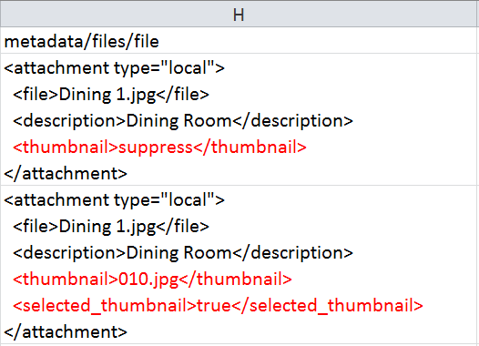

Figure . Examples of suppressing, specifying and selecting thumbnails in Custom Attachments

### Uploading to Multiple Collections

By default, when creating new items they are created in the collection specified in the **Collection** drop-down on the main form. It is also possible to specify different collections per row in your CSV. Note that this feature cannot be used when updating existing items or creating new versions from existing items.

To specify a Collection per row add a column to your CSV with a single collection name per row. The **Column Data Type** for the column should be set to “Collection” and the column heading can be anything. If a cell in the column is left blank then the collection specified in the **Collection** drop-down on the main form will be used. If a collection is specified that is not in EQUELLA, or the EBI username does not have permission to create items in, an error is raised and the row skipped.

### Attaching EQUELLA Resources

Other EQUELLA resources — items and item attachments — can be attached to an EQUELLA item in the same institution. This can be accomplished with the EBI by using the “EQUELLA Resources” **Column Data Type**.

As with “Attachment Locations” and “URLs” columns, the column heading should be the metadata target of the EQUELLA resource attachments (as used in the corresponding collection’s EQUELLA wizard configuration if applicable). A column of “EQUELLA Resource Names” **Column Data Type** allows the names of the link descriptions to the EQUELLA Resources to be specified if the default should be overridden. As with “Attachment Locations” and “URLs” columns, multiple EQUELLA resources can be attached to the one item by using delimiters or multiple “EQUELLA Resources” columns.

There are two formats that can be used for the specifying EQUELLA Resources in your CSV: by item UUID and by source identifier.

#### Specifying EQUELLA Resources by UUID

If the UUIDs of the EQUELLA resources to attach are known then an EQUELLA resource can be specified by UUID:

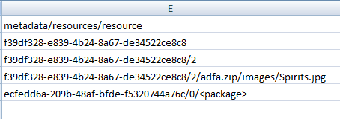

Figure 53. An example “EQUELLA Resources” column for attaching EQUELLA items of known UUIDs

The supported formats for EQUELLA resources are as follows:

|  |  |
| --- | --- |
| **EQUELLA Resource Format 1** | *item uuid* |
| **Example** | “b515cc8d-d6b0-4a50-bb09-6c87920804b8” |
| **Behavior** | The latest live version of the specified item itself will be attached as an EQUELLA resource |
| **Default Attachment Name** | The item name |

|  |  |
| --- | --- |
| **EQUELLA Resource Format 2** | *item uuid*/*item* *version* |
| **Example** | “b515cc8d-d6b0-4a50-bb09-6c87920804b8/3” |
| **Behavior** | The specified version of the specified item itself will be attached as an EQUELLA resource |
| **Default Attachment Name** | The item name |

|  |  |
| --- | --- |
| **EQUELLA Resource Format 3** | *item uuid*/*item version*/*relative attachment path* |
| **Example** | “b515cc8d-d6b0-4a50-bb09-6c87920804b8/3/docs/intro.pdf” |
| **Behavior** | The attachment of the specified item version will be attached as an EQUELLA resource. Use item version 0 for the latest live version. |
| **Default Attachment Name** | The attachment description |

|  |  |
| --- | --- |
| **EQUELLA Resource Format 4** | *item uuid*/*item version*/<package> |
| **Example** | “521b2225-54e0-4d7b-a4d6-45243fcd7889/1/<package>” |
| **Behavior** | The IMS or SCORM package attached to the specified item version will be attached as an EQUELLA resource |
| **Default Attachment Name** | The package name |

#### Specifying EQUELLA Resources by Source Identifier Directives

If the UUIDs of the EQUELLA resources to attach are *not* known then resources can be specified by source identifiers (for details about source identifiers see section 6.9.1 , page 58). This feature is particularly useful if uploading the EQUELLA resources with the EBI either in the same run, or a preceding run, as the items themselves.

Specifying EQUELLA resources by source identifiers is done using any of the same formats as resources specified by UUID except that in place of a UUID a *source identifier directive* is included. For example:

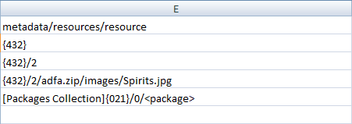

Figure 54. An example “EQUELLA Resources” column for attaching EQUELLA items of unknown UUIDs

The EBI uses the source identifier directive to determine the UUID of the referenced resource. Following are the allowed formats for source identifier directives:

|  |  |
| --- | --- |
| **Source Identifier Directive Format 1** | {*source identifier*} |
| **Example** | “{R-32-544}” |
| **Behavior** | Resolves to the UUID of the item of a matching source identifier in the same collection as the item being uploaded |

|  |  |
| --- | --- |
| **Source Identifier Directive Format 2** | [*collection name*]{*source identifier*} |
| **Example** | “[Resources Collection]{R-32-544}” |
| **Behavior** | Resolves to the UUID of the item of a matching source identifier in the specified collection. Uses the same source identifier as specified in items being uploaded. |

|  |  |
| --- | --- |
| **Source Identifier Directive Format 3** | [*collection name*][*absolute* *XPath*]{*source identifier*} |
| **Example** | “[Resources Collection][/xml/metadata/@resourceid]{R-32-544}” |
| **Behavior** | Resolves to the UUID of the item of a matching source identifier in the specified collection. Uses the source identifier found at the specified XPath. |

### Custom Attachments

EQUELLA supports attachment types other than file attachments and simple URLs. For example, EQUELLA attachments can also be YouTube videos and Flickr media. Such attachments require specialized metadata to be added to the /xml/item/attachments/attachment element in the item’s metadata for each of these attachments. The EBI supports the creation of such attachment elements using what are called **Custom Attachments**.

To create item attachments other than the standard file attachments or URL links /xml/item/attachments/attachment elements need to be created in items. This can be done by specifying a CSV column with **Column Data Type** of **“Custom Attachments”**. Inside the column, a cell should contain an XML fragment of the required attachment elements. As with URLs and standard attachments, the column heading should be the metadata target of the corresponding Attachments control in the wizard.

For example, to create an item with two attachments, a YouTube video and a Kaltura-hosted video, you would use a Custom Attachments value such as this (Figure 55):

<attachment type="**custom**">

<type>youtube</type>

<file />

<description>Equella tour</description>

<attributes>

<entry>

<string>playUrl</string>

<string>http://www.youtube.com/v/uELyRAlRs&fs=1&source=uds&autoplay=1</string>

</entry>

<entry>

<string>thumbUrl</string>

<string>http://3.gvt0.com/vi/uELyRAlRs/default.jpg</string>

</entry>

<entry>

<string>videoId</string>

<string>uELyRAlRs </string>

</entry>

</attributes>

</attachment>

<attachment type="**custom**">

<type>kaltura</type>

<uuid>de077d83-4b99-439b-9e5e-ef566d454226</uuid>

<file />

<description>Nature Video</description>

<attributes>

<entry>

<string>title</string>

<string>Nature Video</string>

</entry>

<entry>

<string>kalturaServer</string>

<string>**846328ab-522a-450b-9764-e52e15e1b6bd**</string>

</entry>

<entry>

<string>thumbUrl</string>

<string> **https://cdnsecakmi.kaltura.com/p/691542/sp/69129200/thumbnail/entry_id/0_crf3ox66/version/100000**</string>

</entry>

<entry>

<string>entryId</string>

<string>**0_crf3ox66**</string>

</entry>

</attributes>

</attachment>

Figure 55. Attachment elements as specified in a Custom Attachment field

The above Custom Attachments value would result in two attachments in the EQUELLA item, the first to a YouTube video and the second to a Kaltura-hosted video.

Notice that an attachment UUID was supplied for the second custom attachment (but not for the first). This demonstrates that when using custom attachments you can, if you wish, provide an attachment UUID rather than leaving it to EQUELLA or the EBI to automatically generate a UUID (as is done for URLs and standard attachments).

Note that though the data in a Custom Attachments CSV cell is technically an XML fragment the column does **not** need to be set for XML Fragments (see section 5.3.1 *,* page 30, to learn more about XML Fragments).

There are several formats for the various types of attachments supported in EQUELLA. Higher versions of EQUELLA support a greater number of attachment types as content support typically increases with each version of EQUELLA. One of the easiest ways of determining the format of attachment elements in EQUELLA is to simply create an attachment using an EQUELLA wizard control and inspect the resulting metadata.

Thumbnails for local file attachments can be controlled in custom attachments by including the elements attachment/thumbnail or attachment/selected_thumbnail. See Section 5.3.5.3 (page 43) for further information about thumbnail control in custom attachments.

### Uploading CAL Content (Australia)

The EBI can be used for uploading copyright-identified content that utilizes EQUELLA’s Copyright Agency Limited (CAL) compliance features.

“Holding” items (e.g. items that register books and journals) can be uploaded without any special EBI settings other than meeting the minimum metadata requirements for saving items to the holding collection.

“Portion” items (e.g. eReserves) should also be uploaded so that they meet minimum metadata requirements for saving items to the portions collection. Additionally, a column of “EQUELLA Resources” should be included so that each portion is linked to a holding item. The link should be to the holding item itself, not any of its attachments. If more than one EQUELLA Resource is specified for the portion item then the EQUELLA Resource column for holding items should be specified first (i.e. furthest left) in the CSV.

Each portion row in the CSV should also have a command option **“CAL_PORTION”**. See section 5.3.3 (page 35) to learn more about command options.

Figure 56 is an excerpt from an example portions CSV showing the columns set in EBI to a column data type of **“EQUELLA Resources”** (column O) and a column data type of **“Commands”** (column P).

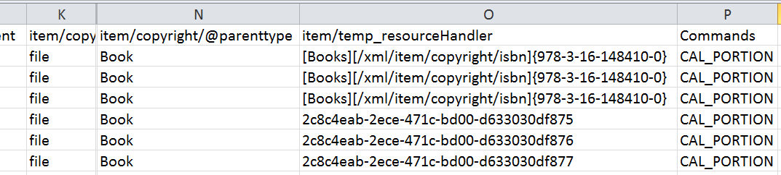

Figure 56. An example of some of the key columns when uploading CAL portions.

The column heading of the EQUELLA Resources column should be the same as the metadata target of the Attachments control configured in the portion collection wizard for linking portions to holdings (minus the leading slash). In the above example the metadata target is /item/temp_resourceHandler. See section 5.3.7  *(*page 44) to learn about how to interlink items using the **“EQUELLA Resources”** column data type.

There are many ways to interlink items using an “EQUELLA Resources” data type in EBI. In the above example the first three rows are linked to the same holding item (in a collection called “Books”) by its ISBN. The next three rows are linked to a holding item by the holding item’s UUID. See section 5.3.7  *(*page 44) to learn other ways to interlink items.

### Attaching Files Without Metadata

You can upload files and attach them to items without the associated attachment metadata by using the **“Raw Files”** column data type. This is unlike when using an **“Attachment Location”** column data type for which the EBI will automatically generate system attachment metadata for each file uploaded i.e. /xml/item/attachments/attachment.

A CSV column of **“Raw Files”** can have any column heading (it will be ignored by the EBI). The data cells can have either file paths (as you would use in an **“Attachment Locations”** column) or a path to a folder. When a folder is specified the EBI will recurse through the folder uploading all files and folders within.

#### Attaching Individual Raw Files

As with Attachment Locations, with Raw Files you can specify a path to a single file. The file will be attached to the item but no corresponding attachment metadata will be generated.

In the following example (Figure 57) a file called “volcano1.jpg” will be attached to the item and no corresponding system attachment metadata. As a result the file will not appear as an attachment link on the item display page and it will not be editable via an Attachments control in a contribution wizard.

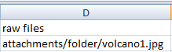

Figure 57. An example of attaching a file with no associated attachment metadata by using the Raw Files column data type.

As with Attachment Locations, a column of corresponding Attachment Names cells can optionally be specified but, unlike when used with Attachment Locations, Attachment Names allow the *name* and *target* *folder* of the file to be specified as it will be attached to the item. It will have no effect on the resource links displayed on the item display page.

In the following example (Figure 58) the source file in the Raw Files column is named volcano2.jpg.

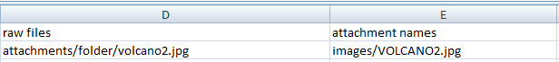

Figure 58. An example of renaming and relocating a “Raw File” by using Attachment Names.

Because a corresponding Attachment Names value is “images/VOLCANO2.jpg” the file will be attached to the item in a sub folder called “images” and will be renamed to “VOLCANO2.jpg”. The following “tilde view” of the item shows the result (Figure 59). Note the name of the file and the folder it is in:

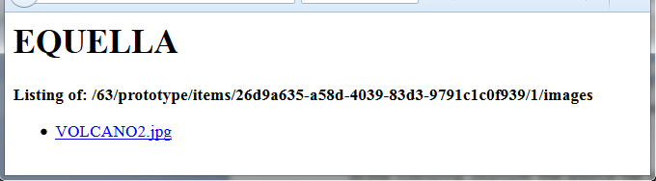

Figure 59. The “tilde view” of the resultant item from the previous example.

#### Attaching a Folder as a Raw File

Using Raw Files you can specify a path to a folder. A path to a folder must be followed by an asterisk (“*”) to signify that all files and folders found inside should be attached to the item.

Attachment Names can optionally be provided but only to specify a folder in the item to locate the source folder structure inside. This folder must also be followed by an asterisk. Following is an example of a CSV with two rows utilizing Raw Files for folders (Figure 60). That entire directory structure and files located below attachments/folder/* on the source computer will be attached to both items. The first item will have the files attached to the root of the item. The second item will have the files attached to a folder called “files”.

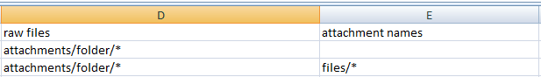

Figure 60. An example of attaching an entire folder structure to an item.

#### Raw Files Used in Conjunction with Custom Attachments

Though Raw Files result in no corresponding system metadata, attachment metadata can still be added through the use of **“Custom Attachments”** (see section 5.3.8 , page 46). The following CSV is an example of a file that is uploaded as Raw Files (and renamed and placed in a subdirectory of the item) and has a corresponding Custom Attachment to provide a link on the item display page and make it editable in a contribution wizard.

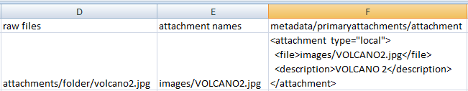

Figure 61. Using Raw Files in conjunction with Custom Attachments.

# Running the Import

The import process is started by clicking the **Start Import** button. The process provides a visual cue to progress by outputting information to the **Log** tab. Figure 62 below shows the output of an import process that ran without error.



Figure 62. An example of the output of an error-free import process

Note the second last line of the log, “**Processing complete (success 3)**”. This line will summarize how many items were processed and indicate if there were any errors.

## Output

The example in Figure 62 indicates that 3 rows were found in the CSV and all three were successfully imported into EQUELLA. The EBI automatically outputs attachment paths, URLs and command options. You can specify additional CSV data to be included in the output by marking columns for **Display** (see Figure 63).

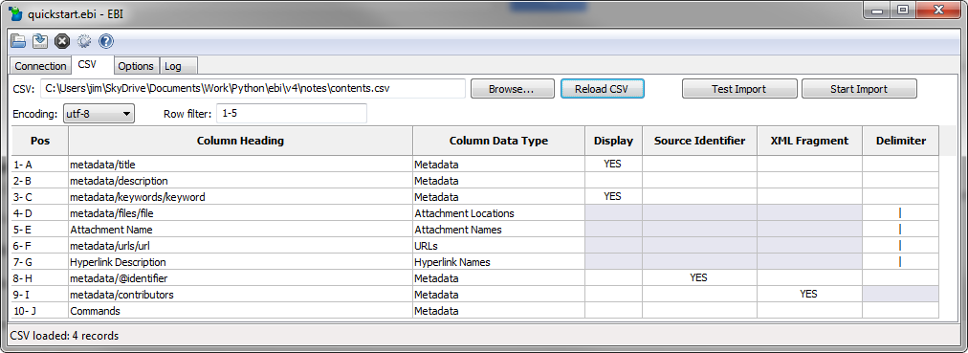

Figure 63. Specifying a column of data to be included in the output display

Setting columns to Display will help you to see which records have been processed and what metadata was imported.

For each run a corresponding log file is automatically created in a folder called logs within the folder where the CSV is located (see Figure 64).

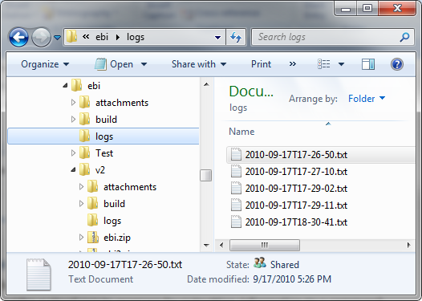

Figure 64. Automatically created log files

The log file is named the date and time the EBI was started. The log file contains the same information that is output to the **Log** tab.

## Stopping or Pausing the Import

You can stop or pause an import process part way through by clicking the **Stop Processing** or **Pause/Unpause Processing** buttons on the EBI’s toolbar (see Figure 65).



Figure 65. The Stop Processing and Pause/Unpause buttons to halt or pause an import or export process

Clicking the **Stop Processing** button will cause the EBI to halt processing immediately. If the EBI is partway through uploading an item the item will not be committed into EQUELLA.

Clicking the **Pause Processing** button will cause the EBI to pause processing. If the button is clicked again the EBI will resume processing (unpause). If the EBI is paused partway through uploading an item the item will not be committed into EQUELLA until it is unpaused.

## Errors

Any errors that may occur are displayed in the log. See section 7.1, , page 70) for common errors. If you are still having trouble understanding the meaning of an error you should copy the error and send it to your EQUELLA administrator or an EQUELLA consultant along with the CSV, log file and the settings file (see section 6.11 , page 63).

## Connecting with a Proxy

The EBI supports connecting to EQUELLA via a proxy server. If you are using EBI on a corporate network and are unable to connect to EQUELLA this may be because you need to use a proxy server. If you are unsure check with your IT support.

To connect to EQUELLA via a proxy got to **Toolbar-> Preferences () -> Advanced**. Here, fill in the **Proxy Server Address** field. The format of the address should be [host]:[port] e.g. “proxy001:8080”.

The EBI provides **Proxy Server Username** and **Proxy Server Password** fields for Basic and Digest Authentication support.

The EBI does not support Microsoft NTLM challenge/response authentication for proxies.

## Required EQUELLA Permissions

The user account in the **Username** fields must have the necessary privileges in the EQUELLA collection to perform the required actions. The following are the minimum privileges needed on items for the various uses of the EBI.

|  |  |
| --- | --- |
| **Field** | **Required Privileges** |
| **Create new items** | CREATE_ITEM  VIEW_ITEM |
| **Edit Existing items** | VIEW_ITEM  DISCOVER_ITEM  EDIT_ITEM |
| **Create new version of existing items** | CREATE_ITEM  VIEW_ITEM  DISCOVER_ITEM  NEWVERSION_ITEM |
| **Delete existing items** | VIEW_ITEM  DISCOVER_ITEM  DELETE_ITEM |
| **Set owner of existing items** | VIEW_ITEM  DISCOVER_ITEM  EDIT_ITEM  REASSIGN_OWNERSHIP_ITEM |
| **Set collaborators of existing items** | VIEW_ITEM  DISCOVER_ITEM  EDIT_ITEM  REASSIGN_OWNERSHIP_ITEM |
| **Exporting items** | VIEW_ITEM  DISCOVER_ITEM |

## EQUELLA Scripts, Workflow and Digital Rights Management

Items created or updated by the EBI respond and conform to scripts, workflow and digital rights management (DRM) in the same way as items managed through an EQUELLA wizard.

### EQUELLA Scripts

If the EQUELLA collection that you are importing content into has an **Expert Save Script** configured the script will be run upon import of new items or updated items (see section 6.9 , page 58). **Expert New Version Scripts**, however, are only run if the VERSION command option is used. Scripts are not run during test runs.

Scripts on wizard controls or wizard pages are not run.

### EQUELLA Workflow

If a **workflow template** is associated with the collection you are importing into then new items and new item versions will progress through workflow as if they were created with an EQUELLA wizard. Workflow is not applied when updating existing items (unless creating new versions).

If you wish to avoid new items going into workflow then remove the workflow template from the collection. However, note that when a workflow template is removed from a collection any items currently in moderation will immediately go live.

### EQUELLA Digital Rights Management

EQUELLA’s **Digital Rights Management (DRM)** can be applied to items by reproducing the metadata in the /xml/item/rights element as the DRM pages in a contribution wizard would produce. This can be done with standard metadata, XML fragments (see section 5.3.1 , page 30) or a combination of both.

## Testing Your Import

Before running the import you will likely want to perform a test run. This can be done by clicking the **Test Import** button. Clicking this button performs the same actions as a real import but without submitting items or attachments to EQUELLA. For this reason it runs faster than a real import, especially one with large attachments. The **Test Import** button is a useful way of verifying your settings and CSV file prior to commencing an import.

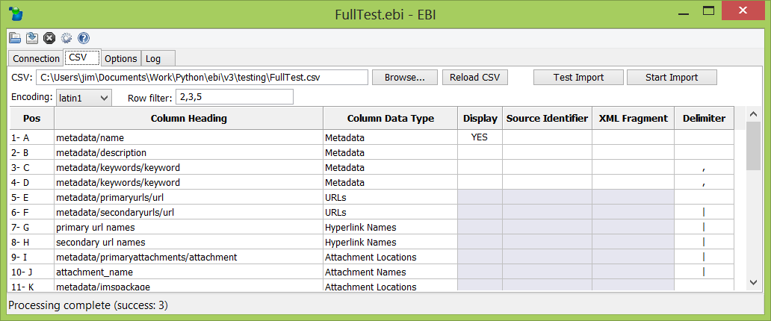

Figure 66. Performing a test run

You can create sample XML files in a test run by checking the check box **Options** tab **-> Save test XML** (see Figure 67).

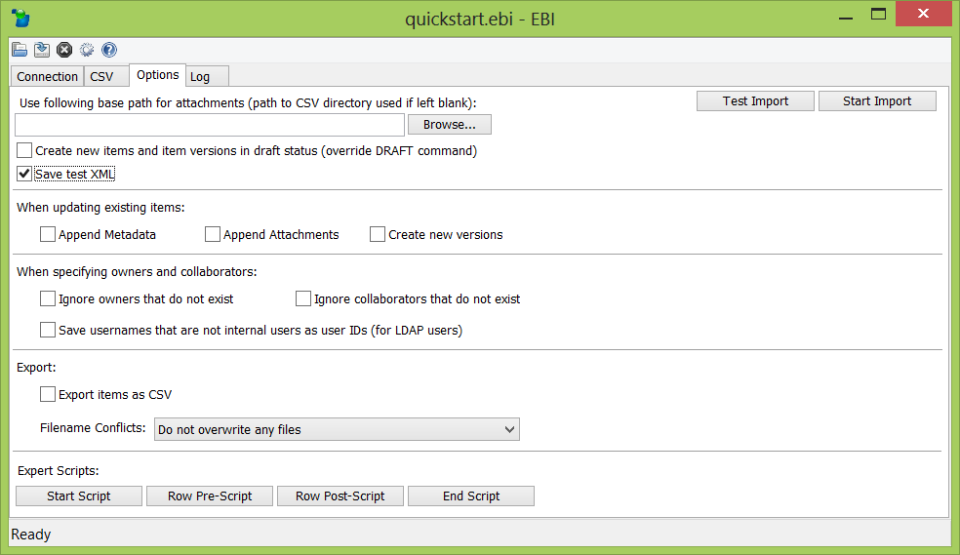

Figure 67. Configuring the EBI to save item XML files on test runs

When this check box is checked the EBI will create sample files in a folder called test_output under the folder containing the CSV. Within this folder the EBI will create one sub folder for each run and one xml file for each item (see Figure 68). This is a convenient way to verify the final item XML without creating items in EQUELLA.

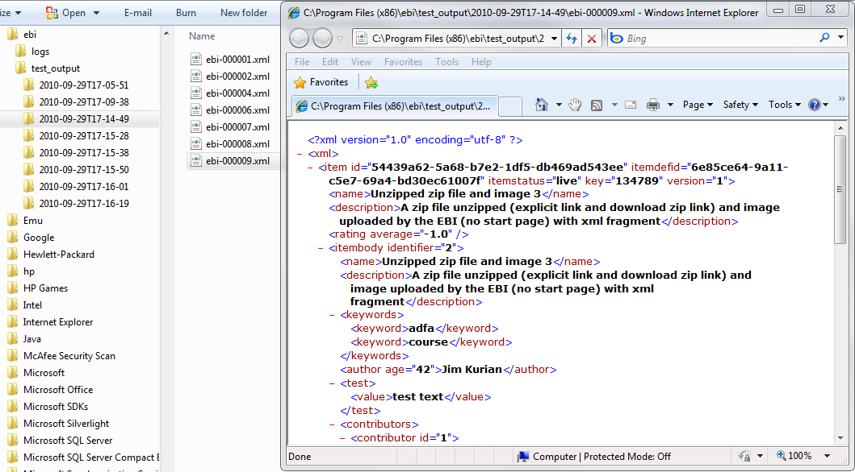

Figure 68. Test item XML produced by the EBI

Note that the item IDs in the test XML files are assigned by EQUELLA and will change witheach test run. They will also be different to the actual item IDs assigned to the records by EQUELLA in a real import run.

Some system metadata will not be available in these documents (e.g. owner details, item history) as much of the system metadata is only calculated by EQUELLA when an item is saved for real.

## Importing Select Rows from Your CSV

It is possible to specify a subset of rows to process (either test or real) and a specific order they should be processed in. This is done by specifying a *row filter*. A row filter instructs the EBI to only import rows with row positions that fall within lists and/or ranges of numbers. The row filter is specified in the **Row Filter** field (see Figure 69).

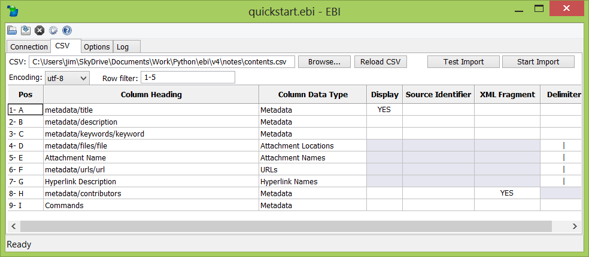

Figure 69. Specifying a subset of rows to import or test import

Some examples of row filters are as follows:

|  |  |
| --- | --- |
| **Row Filter** | **Outcome** |
| 1, 3, 9 | Process rows 1, 3 and 9 in the CSV |
| 15-23 | Process rows 15 to 23 inclusive |
| 10- | Process all rows from 10 onwards |
| 1, 3, 12-18, 21- | Process rows 1, 3 then rows 12 to 18, then all rows 21 onwards |
| 6-11, 3, 2, 1 | Process rows 6 through 11 then row 3, row 2 and finally row 1 |
| 2, 1-3, 2, 2, 2-3 | Process row 2 then row 1 then row 3 |

The last example highlights a row filter with duplicate rows. In this event the EBI only imports each *distinct* row once and in the order each distinct row first appears in the row filter.

Note that a row position of a CSV row means its position *discounting the headings row*. Technically, the first row in the CSV file is actually the headings row. However, the second row in the CSV is the first *data row* and therefore is considered to have a row position of 1 for the purposes of row filters.

If **Row Filter** is left blank the EBI will process all rows in the CSV.

## Updating Existing Items in EQUELLA

Using the EBI not only can you create new items in EQUELLA but you can also update existing ones.

### Updating Existing Items using Source Identifiers

One way of updating existing items is by specifying a *source identifier* field that can match the records in the CSV with items in EQUELLA. This can be useful if your CSV already contains IDs from another system or generated in the CSV itself.

Create a field in the EQUELLA schema that a source identifier can be stored in. The field can be named anything and may either be an element or an attribute. Check the **Index for Advanced Searches** check box. See the example in Figure 70 of a source identifier attribute named “identifier”.

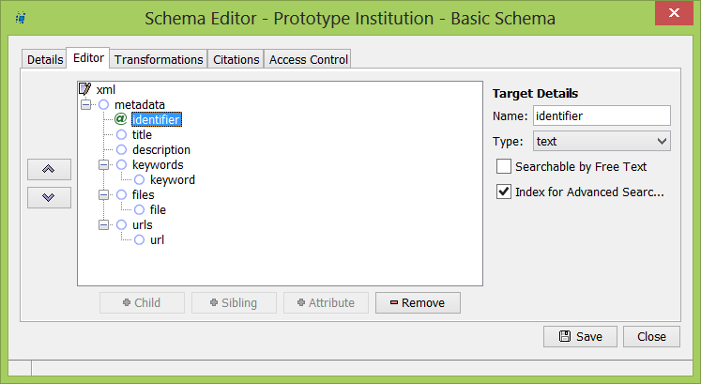

Figure 70. Specify a “source identifier” in EQUELLA

Now in the CSV a column of source identifiers is required. These can be of any format, numerical or alphanumerical, as long as they are unique to each row of the CSV. For example, “1”, “DFWTE”, “232-3423”, “S342343-B” are all valid source identifiers. In the column heading specify the XPath that matches the EQUELLA schema field where the source identifier will be stored. An example of this is shown in Figure 71.

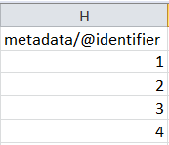

Figure 71. Specifying a column of unique source identifiers in the CSV

Note that source identifiers **cannot contain apostrophes**.

In the EBI’s main form specify the column of the source identifiers in the **Source Identifier** field (see Figure 72).

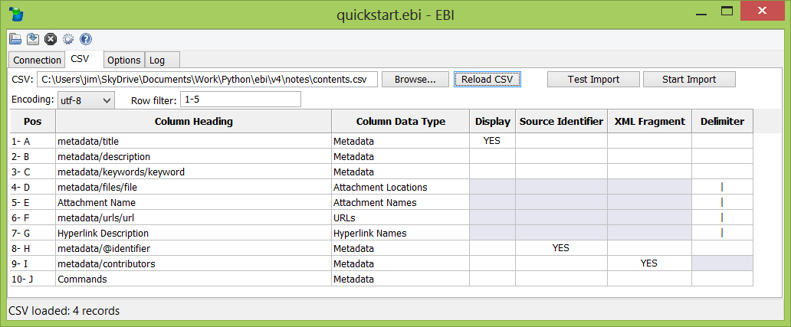

Figure 72. Specify the CSV column for unique source identifiers in the EBI

Now when an import is run (test or real) for each row in the CSV the EBI will search EQUELLA for an item that matches the row’s source identifier. If it finds a matching item rather than creating a new item in EQUELLA it will update the matching item (or create a new version if used in conjunction with the VERSION command option).

By default, only items with a status of “live” will be updated with source identifiers.

### Updating Existing Items using Target Identifiers

If you know the EQUELLA item IDs that you are updating another way of updating existing items is by specifying what are called *target identifiers*. Target identifiers are the UUID EQUELLA item IDs of the existing items in EQUELLA. To do this, in your CSV include a column of item IDs (see Figure 73).

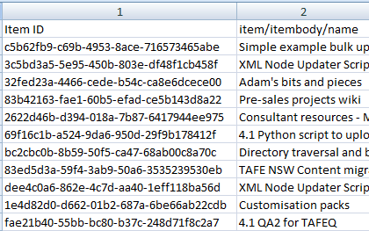

Figure 73. Specifying a column of Target Identifiers

You can name the column heading of this column anything or leave it blank. In the EBI select “**Target Identifiers**” for the **Column Data Type** for the corresponding column.

When run, the EBI will attempt to match the target identifier of each row against an existing item in EQUELLA and update that item. For any rows with blank target identifiers new items are created. If a target identifier is provided that does not exist in EQUELLA an error will be returned and the EBI will move on to the next row.

By default, using target identifiers will see live items updated (or new versions created if used in conjunction with the VERSION command option). However, unlike when using source identifiers, if no live items are available then the first non-live item will be updated (e.g. draft, moderating, archived etc)

### Targeting Particular Item Versions

By specifying a column of item versions and setting the column data type as “Target Versions” you can update a particular version of an item regardless of its status. Target versions can be used in conjunction with either source identifiers or target identifiers.

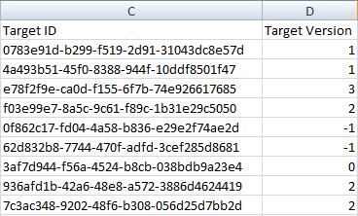

Figure 74. Specifying a column of Target Versions

When using target versions each row can specify an explicit item version (e.g. 1, 2, 3 etc) or an implicit item version with a value of either 0 or -1. Using an item version of 0 will see the latest live version of an item updated. Using an item version of -1 will see the latest version of the item regardless of its status.

### Creating New Versions

By default, when updating existing items with the EBI the latest version is edited. Optionally, you may instruct the EBI to create new versions. This can be done by checking **Options** tab **-> Create new versions** checkbox.

You can also specify individual rows to generate new versions by using the “VERSION” Command Option (see section 5.3.3 , page 35).

### Updating Existing Metadata without Uploading Attachments

It is possible to update the metadata of existing items without uploading and overwriting existing attachments. This can be done by configuring the EBI such that no columns have a **Column Data Type**of “**Attachment Locations**” or “**URLs**”. This technique will work regardless of whether the matching of existing items is done with source identifiers or target identifiers

An existing configuration can be easily reconfigured to update only metadata by setting the **Column Data Type** of attachment location columns and URL columns to “**Ignore**” (see Figure 75).

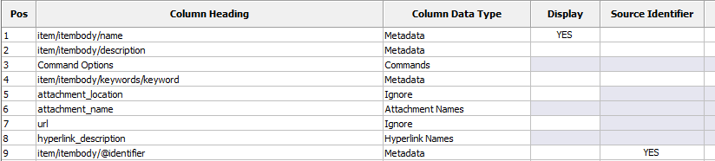

Figure 75. Modifying a configuration to update metadata of existing items but not attachments

### Replacing and Appending to Metadata in Existing Items

By default, when updating existing items with the EBI existing item metadata is cleared and replaced by the metadata specified in the CSV. Optionally, you may instruct the EBI to replace only the metadata specified in the CSV or to *append* the metadata in the CSV to the item’s existing metadata. This can be done by checking **Options** tab **-> Existing Metadata** drop-down.

Setting the Existing Metadata drop-down to “Replace only specified metadata” will have EBI ignore any existing custom metadata nodes in the item metadata not specified in the CSV thus leaving them untouched. Nodes that are specified in the CSV will be cleared.

Setting the Existing Metadata drop-down to “Append to Existing metadata” will have EBI leave any existing custom metadata nodes that are in the item and specified in the CSV untouched. Nodes that are specified in the CSV will also be left untouched but *added* to with the metadata specified in the CSV.

You can also specify individual rows to replace and append specified metadata by using the “REPLACEMETA” and “APPENDMETA” Command Options respectively (see section 5.3.3 , page 35).

Note that if you are using source identifiers, even when specifying to append metadata, the node identified as the source identifier *will not* be appended to but rather replaced. This is to prevent duplicate source identifiers appearing in an item.

### Appending Attachments to Existing Items

By default, when updating existing items with the EBI existing attachments are replaced by any attachments specified in the CSV. Optionally, you may instruct the EBI to *append* the attachments specified in the CSV to the item’s existing attachments. This can be done by checking **Options** tab **-> Append attachments** checkbox.

You can also specify individual rows to append attachments by using the “APPENDATTACH” Command Option (see section 5.3.3 , page 35).

## Saving Items in Draft Status

By default, when items or new versions of items are created in EQUELLA with the EBI they are made immediately live (or in moderation if workflow applies). Optionally, you may instruct the EBI to create items or item version in “draft” status. This can be done by checking **Options** tab **-> Create new items and item versions in draft status** checkbox.

You can also specify individual rows to create new items or item versions in draft status by using the “DRAFT” Command Option (see section 5.3.3 , page 35).

## Saving Your Settings

You can save your settings to a settings file and load previously used settings by using the EBI’s toolbar (see Figure 76).



Save settings

Open settings file

Figure 76. Tool bar buttons for opening and saving settings files

Settings files have the extension “.ebi”. If necessary, it is possible to copy an existing settings file and edit it with a text editor. Note, however, that the password setting in a settings file is encrypted and can only be modified with the EBI. Control-S or Command-S is a shortcut for saving your settings.

## Setting Preferences

The EBI’s preferences settings allow you to configure the behavior of the EBI itself. The **Preferences** dialog is accessed by using the preferences toolbar button (see Figure 77).

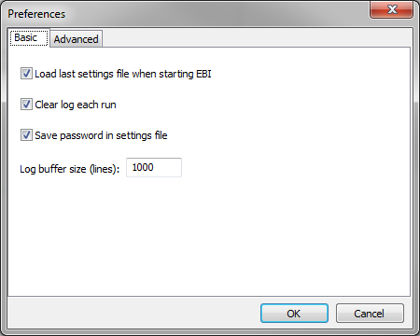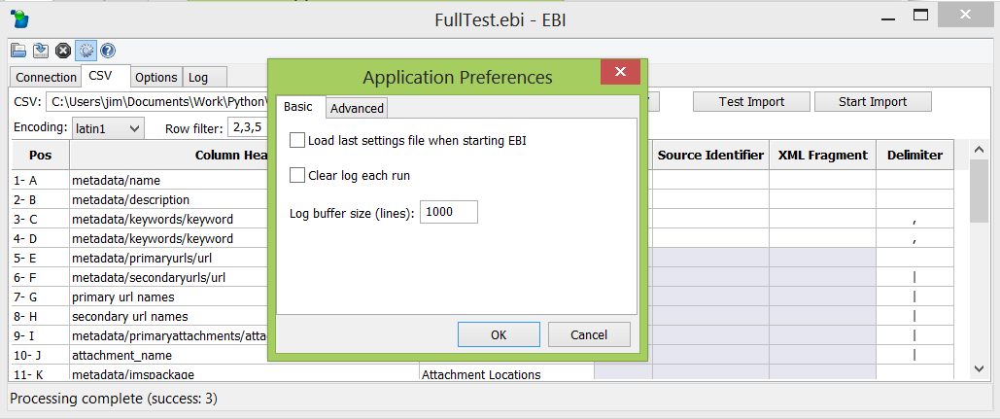

Figure 77. Setting application preferences

The following settings are available in the **Preferences** dialog:

|  |  |
| --- | --- |
| **Basic Tab** | |
| **Field** | **Action** |
| **Load last settings file when starting EBI** | If this setting is checked, when next launched the EBI will automatically load the last opened or saved settings file (*.ebi). |
| **Clear log each run** | When checked the EBI will clear the log prior to starting each test or real run. |
| **Save password in settings file** | When checked, upon save the EBI will encrypt and save the password in the connection tab to settings files. |
| **Log buffer size (lines)** | This controls the maximum amount of text displayed in the EBI’s **Log** tab. Will revert to default (1,000 lines) if cleared. |

|  |  |
| --- | --- |
| **Advanced Tab** | |
| **Field** | **Action** |
| **Proxy Server Address** | The address of your network’s proxy server if one is required to connect to EQUELLA (see section 6.4 , page 54). |
| **Proxy Server Username** | The username for basic or digest authentication with your network’s proxy server. |
| **Proxy Server Password** | The password for basic or digest authentication with your network’s proxy server. |
| **Debug mode** | When checked the EBI will output to the display and log files additional diagnostic information particularly when errors occur. |
| **Network logging** | When checked network diagnostic information is displayed and recorded in the log for each HTTP request made to EQUELLA. **WARNING:** log files grow rapidly when this setting is in effect, potentially more than 50Kb per item. To avoid excessively large log files only use this setting with a small set of records per run. |
| **Attachment chunk size (bytes)** | Controls the size of each “chunk” that attachments are broken up into during upload. Each chunk is transmitted as a single HTTP or HTTPS request. Will revert to default (2 MB) if cleared. |

These settings and others are stored in an automatically created “global” settings file. See section 7.6 , page 92, for more information.

## Saving Item IDs of Imported Items

It is possible to produce a list of item IDs assigned to the items that you imported. Do this by including an empty column in your CSV and setting its **Column Data Type** to “**Item ID**” (you can give it any column heading you wish). In doing this the EBI will create a copy of your CSV file in a sub folder called receipts found within the folder containing the CSV (see Figure 78).

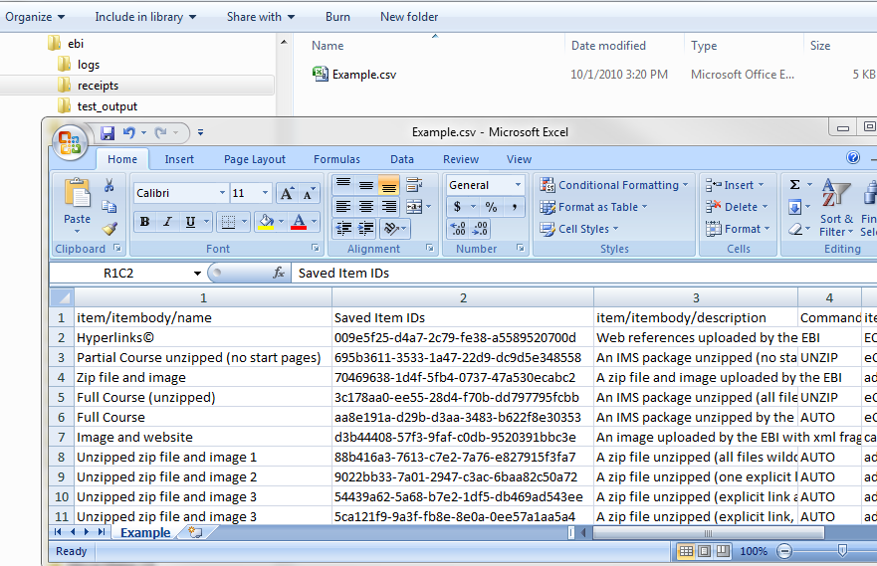

Figure 78. Producing a list of item IDs of imported items

This copy of the CSV is created once the import is completed or halted. Amongst other uses, this can be used for producing a CSV of target identifiers for updating the imported items in the future.

By including a column with a column data type of “**Item Version**” the item version can also be saved.

By including a column with a column data type of “**Row Error**” any errors encountered when attempting to import a row will be saved to the CSV copy.

## Exporting Items

The EBI can be used for exporting metadata and attachments from EQUELLA. This is done by checking **Options** tab **-> Export Items as CSV**. In this mode the EBI will re-label the **Test Import** and **Start Import** buttons as **Text Export** and **Start Export** respectively.

When the **Start Export** button is clicked EBI will iterate through items in EQUELLA, populating the loaded CSV and downloading attachment files as it goes. Attachment files will be downloaded to the CSV folder or the folder specified in the base path in **Options**.

You can export item IDs and item versions by including columns with a column data type of “**Item ID**” and “**Item Version**” respectively.

### Exporting a Subset of Items

By default all live items in the collection specified on the **Connection** tab will be exported. Any pre-existing rows in the CSV will be erased (except the header row). Row filters (see section 6.8 , page 57) can be used to limit the number of items exported.

If a **Collection** column is provided in the CSV then all collections in the EQUELLA institution will be exported and the collection column will be populated with collection names.

A subset of items from the specified collection(s) can be exported by specifying a WHERE clause in **Options** tab **-> WHERE clause**.

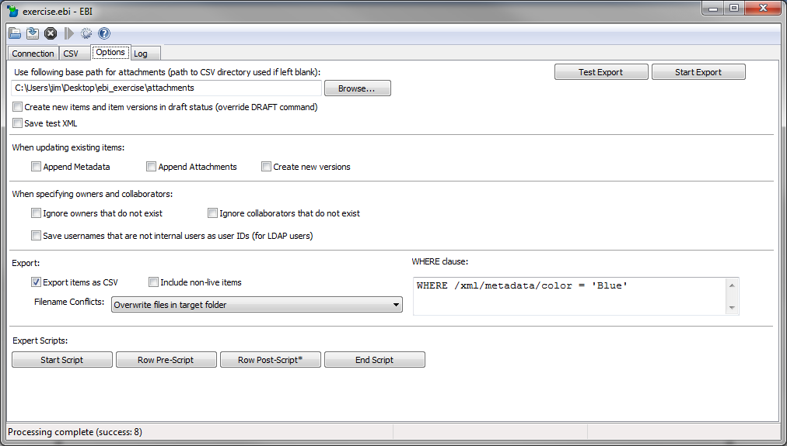

Figure 79. Using a WHERE clause to export a defined set of items

A full description of EQUELLA’s WHERE clause syntax is provided in section 7.2 , page 78.

By default only live items are exported. By checking **Options** tab **-> Include non-live items** items of any status will be exported.

### Using Identifiers to Export Individual Items

**Source Identifiers** (see section 6.9.1 , page 58) and **Target Identifiers** (see section 6.9.2 , page 60) can be used for selecting individual items for export based on IDs (item IDs or custom IDs) specified in the CSV (see figures below).

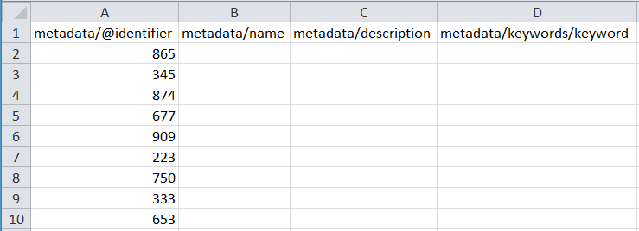

Figure 80. An example of a CSV for exporting items from EQUELLA based on Source Identifiers

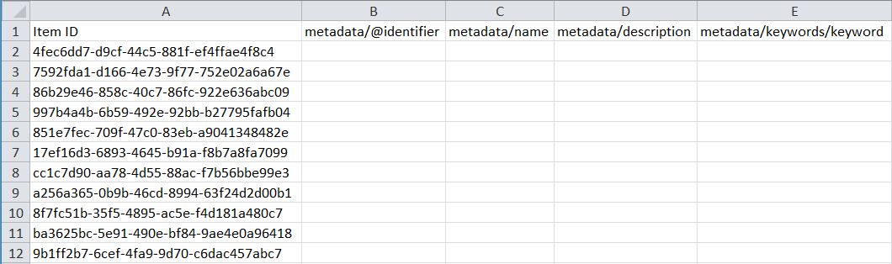

Figure 81. An example of a CSV for exporting items from EQUELLA based on Target Identifiers

If using Source Identifiers with a “Collection” column it is possible to export items from more than one collection in the one run (the **Collection** drop-down will be ignored). If using Target Identifiers, items can be exported from any collection in the one run regardless of the presence of a “Collection” column.

By default, when using Source Identifiers or Target Identifiers only live items will be exported. However, by using **Target Versions** items of any status can be exported. For more information about Target Versions see section 6.9.3 , page 61. Alternatively, checking **Options** tab **-> Include non-live items** the highest version of the matching item will be exported regardless of its status.

### Conflicting Filenames

When exporting attachments, files from different items may have the same names and since EBI exports all files into the same folder there may be filename conflicts. **Options** tab **-> Filename Conflicts** allows you to decide what EBI should do in such cases. The options are the following:

|  |  |
| --- | --- |
| **Option** | **Effect** |
| **"Do not overwrite any files"** | EBI will create subfolders if it encounters any same-named named files in the target folder (DEFAULT BEHAVIOR) |
| **"Overwrite files in target folder"** | EBI will overwrite any same-named files in the target folder existing prior to export and create subfolders for same-named files it has downloaded in the current export run |
| **"Overwrite files with same names"** | EBI will overwrite all files of the same names regardless if they existed in the target folder prior to export or from previous items in the same export run |

### Limitations in the Export Function

For simple content the export capability will produce a CSV that can be used, without any modifications, for re-importing content back into EQUELLA. However, EBI’s CSV export function does not support some of the more advanced EBI features. Features **not** supported (i.e. not exportable) are the following:

* EQUELLA Resources (EQUELLA resource attachments are not supported)
* Custom Attachments (only simple files, SCORM, IMS and zip files are exportable)

XML fragments and XPath indexes should be used with care. Whilst the export function supports both of these features complex metadata that uses “intertwined” XML fragments and XPaths may require some testing and fine-tuning to support smooth, repeatable two-way import/export of content between a CSV and EQUELLA.

## Expert Scripting

For those comfortable with programming, the EBI supports powerful scripting capabilities called **Expert Scripts**. Amongst other uses, Expert Scripts allow you to precisely control how CSVs are interpreted for import into EQUELLA and how EQUELLA items are parsed and formatted for export out of EQUELLA.

Expert Scripts are configured by clicking the Expert Script buttons in the **Options** tab (see Figure 82).

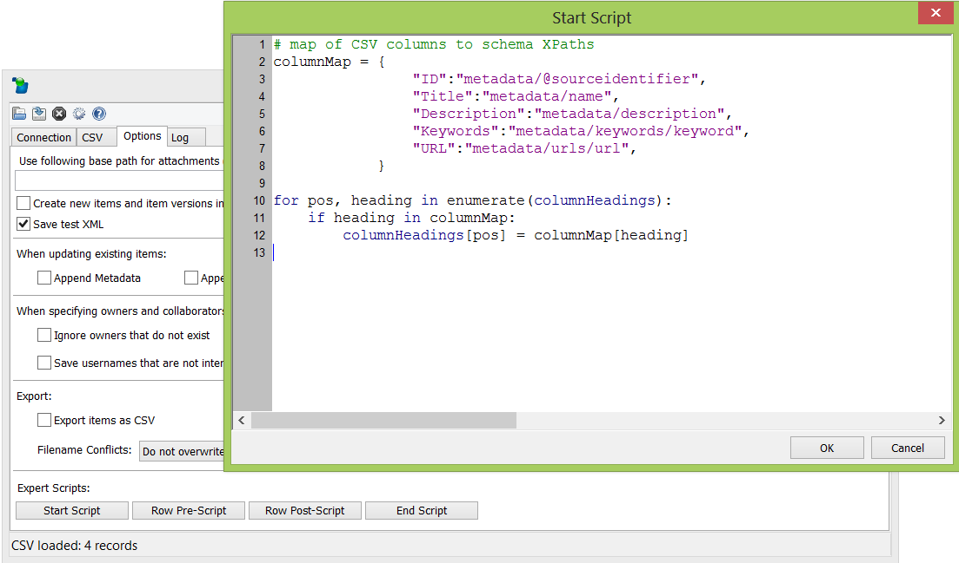

Figure 82. Configuring Expert Scripts in Options

There are four types of Expert Script that can be written:

* **Start Script** – This script is executed by the EBI before processing any rows or items. It is only executed once for each test or real run. It could be used, for example, performing a custom validation of the CSV prior to import.
* **Row Pre-Script** – This script is executed on every row imported or every item exported. It is executed as soon as a row or item is read from EQUELLA and *before* any processing by the EBI. It could be used, for example, pre-processing the row data of the CSV prior to the EBI converts the data to item XML.
* **Row Post-Script** – This script is executed on every row imported or every item exported. It is executed *after* a row or item is read from EQUELLA and processed by the EBI but prior to being added to EQUELLA (or a CSV during export). It could be used, for example, adjusting the XML produced by the EBI prior to uploading to EQUELLA.
* **End Script** – This script is executed by the EBI after processing all rows or items. It is only executed once for each test or real run. It could be used, for example, producing a custom outcome report of the import or export.

Figure 83 below shows at which point in a process run (import or export) that each script is executed by the EBI.



Figure 83. The context of each type of Expert Script during an EBI import or export run

EBI Expert Scripts are written in the Python programming language (<http://www.python.org>). As well as the standard Python libraries, Expert Scripts have a number of objects available to them for reading and writing data as well as controlling and viewing the process flow of the EBI. A complete reference for the EBI’s Expert Scripting object model is provided in , page 81).

Examples Expert Scripts are provided in , page 85.

## Command Line Operations

The EBI can be started non-visually from a command prompt based on the settings in a settings file (see section 6.11 , page 63). In non-visual mode the EBI suppresses the main form and runs using the settings from a settings file. This can be useful for running the EBI as a scheduled task (e.g. a cron job or a Windows Scheduler task).

### Windows

The settings filename can be expressed as a relative path from your current directory.

|  |  |
| --- | --- |
| **Command** | **Behavior** |
| ebi.exe –start <settings filename> | Run an import non-visually |
| ebi.exe –test <settings filename> | Run a test import non-visually |
| ebi.exe <settings filename> | Open the EBI visually |

### Macintosh

The settings filename must be expressed as a **full** **absolute path**. Treat the ebi package as a directory with filename ebi.app.

|  |  |
| --- | --- |
| **Command** | **Behavior** |
| ebi.app/Contents/MacOS/ebi –start <settings filename> | Run an import non-visually |
| ebi.app/Contents/MacOS/ebi –test <settings filename> | Run a test import non-visually |
| ebi.app/Contents/MacOS/ebi <settings filename> | Open the EBI visually |

### Linux

Make certain that Python is installed and in your path environment variable. The settings filename can be expressed as a relative path from your current directory.

|  |  |
| --- | --- |
| **Command** | **Behavior** |
| python ebi.py –start <settings filename> | Run an import non-visually |
| python ebi.py –test <settings filename> | Run a test import non-visually |
| python ebi.py <settings filename> | Open the EBI visually |

**Note:** Evenin command line mode the EBI **requires a graphical user interface** (GUI) or desktop environment be present in Linux.

### Examples

Starting an import run non-visually on Macintosh:

**ebi.app/Contents/MacOS/ebi -start /Users/jimk/Documents/training_load.ebi**

Starting a test import run non-visually on Windows:

**ebi.exe -test "c:/my documents/test run.ebi"**

Launching the EBI visually with a settings file loaded on Linux:

**python ebi.py work_in_progress.ebi**

# Appendices

## Appendix A: Tips and Troubleshooting

### General Tips

#### Getting Started

The EBI works well when configured correctly but if you are using it for the first time it can take some time and effort to get the CSV and settings exactly right.

The best approach is to *start with a simple upload* of a handful of files or hyperlinks with say nothing more than a couple of metadata fields (e.g. title and description). This can be done by following the quick start guide in section 3 , page 11.

Once you have a simple upload working gradually add additional and more complex metadata and content. Before using advanced features carefully read the relevant sections of this manual.

#### Microsoft Excel®

An excellent tool for producing CSV files is Microsoft Excel®. Use Microsoft® Excel’s “**Save As…**” command and set “**Save as type**” to “**CSV (Comma delimited)(*.csv)**”.

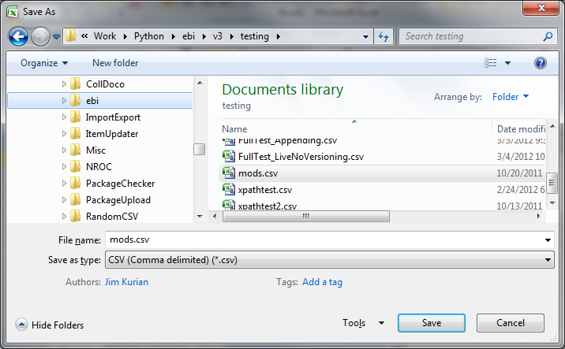

Figure 84. Using Microsoft Excel® to produce a CSV file

Among other benefits, CSV files produced by Excel automatically have the necessary formatting for handling commas.

In some errors the EBI identifies columns by their position number. For convenience, you can configure Excel to display numerical column headings rather than alphabetic.

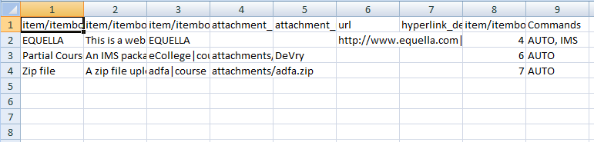

Figure 85. Microsoft® Excel configured to display numeric column headings

This is done by checking the “R1C1 reference style” setting found in **Office Button -> Excel Options -> Formulas** in Excel 2007 and **Tools -> Options -> General** tab in Excel 2003.

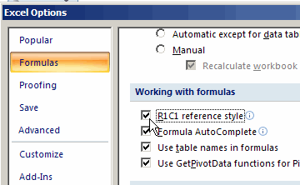

Figure 86. Setting Microsoft® Excel to display numberic column headings

### Troubleshooting

Below are some common problems and corresponding solutions.

#### The EBI’s main screen fails to launch

1. Make certain you are not using the –start or –test command line arguments
2. Make certain that you have installed (i.e. extracted or copied the ebi folder/package) to a location that has read/write privilege

#### The EBI says it successfully imported items but I can’t find them in EQUELLA

1. Ensure that you are performing a real run using “Start Import” and not a test run using “Test Import”
2. When looking for your freshly imported items check that your user account has the necessary privileges to the EQUELLA collection. Your account will need at least DISCOVER_ITEM and VIEW_ITEM privileges to find the items in EQUELLA. See the *EQUELLA Security Guide* for more information.
3. Verify that the items are not in workflow moderation. If the collection that you imported into has a workflow template applied to it then items will likely be created with a status of “Moderating” and won’t appear in standard searches.

#### Item titles and descriptions are not displaying properly in EQUELLA

1. When viewing your imported items in EQUELLA they may appear without a title or description and instead the titles may be displayed as the UUID of the item (See Figure 87):

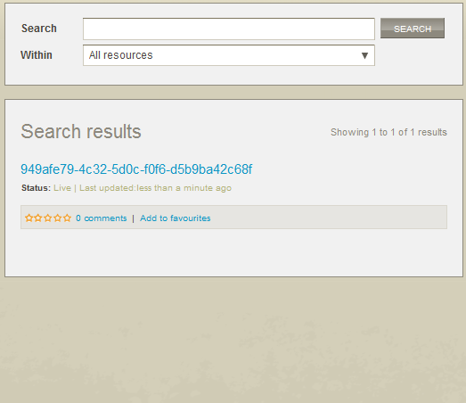 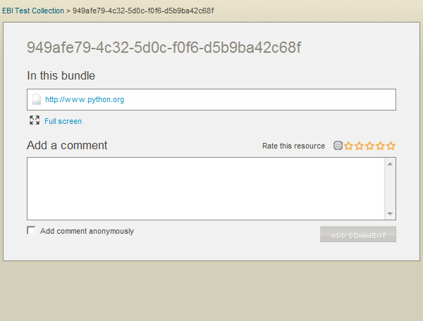

Figure 87. Item titles incorrectly appearing as UUIDs and descriptions missing entirely

This is caused by failing to populate the special **Resource Name Path** and **Resource Description Path** nodes of the item’s XML. These special nodes are set in the EQUELLA schema configuration via the EQUELLA Admin Console.

To correct the problem, first look up in the EQUELLA Admin Console the XPaths for the Resource Name Path and Resource Description Path of the schema used by the collection you are attempting to populate (see Figure 88).

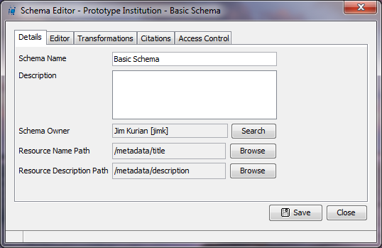

Figure 88. Where to find the XPaths of the nodes to update to set an item’s name and description

Now check that the XPaths in the column headings of your CSV for your titles and descriptions match these values (minus the leading forward slash).

In the example of Figure 88 **Resource Name Path** is configured as /metadata/title and **Resource Description Path** is set to /metadata/description. A corresponding CSV should use these XPaths (minus the leading forward slash) in the column headings for the title and description columns such as in the example CSV in Figure 89 below.

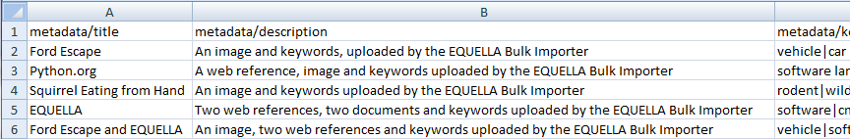

Figure 89. An example CSV with column headings correctly specified to populate the schema of Figure 88

#### The EBI can’t find my attachments

1. Make certain that the column with the attachment paths is correctly set as “**Attachment Locations**” for its **Column Data Type**.
2. If the paths to the attachments in the csv are *absolute* paths (e.g. c:\my documents\attachments\FordEscape.jpg) double-check that they are correct.
3. If the paths to the attachments are *relative* paths make certain they are *relative to the folder your CSV file is in*. For example, if an attachment path is specified as attachments\FordEscape.jpg then the attachments folder must be a subfolder of the folder the CSV file is in.
4. If you have multiple attachments per item and CSV row make certain that you have specified a delimiter

#### Attachments aren’t appearing in my items (yet no errors)

1. Ensure that the column in your CSV where you specify the file names has a **Column Data Type** of “Attachment Locations”.

#### Attachments are not appearing in the EQUELLA wizard

1. If the attachments appear in the item display page but not in the wizard then custom metadata referencing the attachments is missing. Ensure that the column heading of the Attachment Locations where the files are specified in the CSV uses an XPath that matches a metadata target of an Attachments Control in the wizard (see Figure 90).

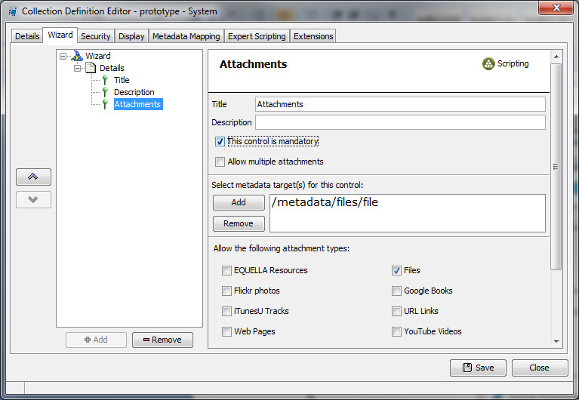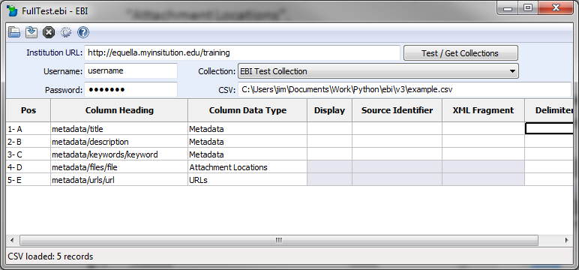 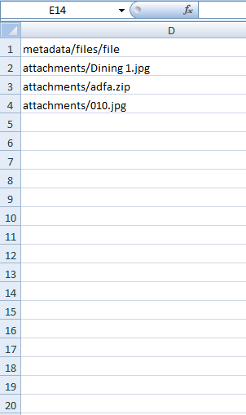

Figure 90. The XPath of an Attachments Locations column or a URLs column should match the metadata target of the Attachments control in the corresponding collection wizard

#### I’m receiving the error “CSV headings do not match the settings”

1. This error occurs when the column headings in the CSV file differ to the column headings in the EBI’s main form. This usually occurs because the CSV columns have been modified or rearranged since it was last loaded into the EBI. This can be rectified by either
   1. clicking the **Reload CSV** button and selecting “**Yes**”. This allows the EBI to update the column settings to match the CSV, or
   2. modifying the CSV so that it matches the columns in the EBI’s main form

#### I’m receiving the error “'utf8' codec can't decode byte”

1. This error occurs when the wrong encoding is being used to read the CSV file. Try changing the encoding to “**latin1**” and re-running the import (see section 5.1.5 , page 22)

#### Special characters are imported incorrectly into EQUELLA

1. This can occur when the wrong encoding is being used to read the CSV file. Try changing the encoding and re-running the import (see section 5.1.5 , page 22)

#### The EBI errors trying to upload file attachments

1. If you receive the following error: “ERROR parsing Full resolution: [Errno 2] No such file or directory” and you are running the EBI on Linux, Unix or Macintosh ensure that you are using forward slashes in your file paths (“/”).

#### A column of metadata won’t import into my item yet there is no error

1. Make certain that the column’s **Column Data Type** has been specified as “**Metadata**” in the EBI’s main form.

#### My multi-value field is not being split into separate fields in EQUELLA

1. Double check that this problem is actually occurring. Multi-value fields are only fully displayed in an EQUELLA wizard if a multi-value control (e.g. a shuffle list control) is mapped to the metadata field. *A non-multi-value control such as an edit box will only display the first value*.

The best way to verify if your multi-value metadata is imported correctly is to either use a custom display template or directly view the item’s underlying metadata.

1. Check that you have specified the correct delimiting character or string for the column in the EBI:

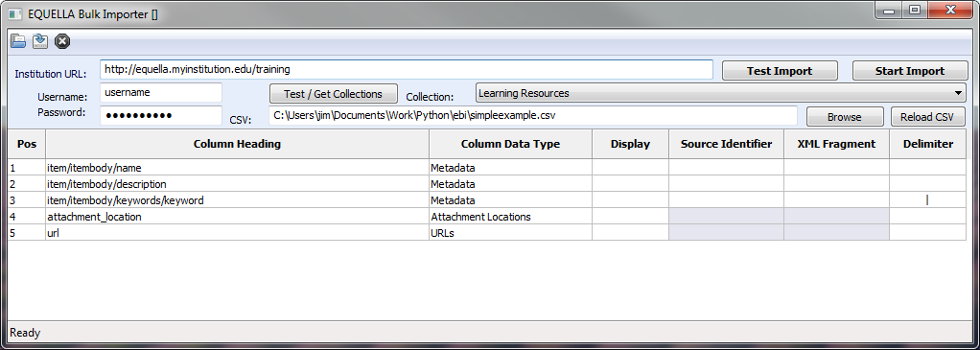

Figure 91. Check that the multi-value columns have been correctly specified

1. Make certain that you are not attempting to split an attribute field. XML does not allow attributes to be repeated. An attribute field’s last node will start with an “@” symbol (e.g. item/itembody/@identifier).

#### Existing items won’t update using source identifiers

1. Make certain the source identifier field in the EQUELLA schema is indexed for power searches
2. Make certain that the Source Identifier field in the EBI is set for the column where the source identifiers exist in your CSV
3. Make certain that the column heading of source identifiers column in your CSV is an XPath that matches the tag or attribute in the EQUELLA schema where the source identifiers are stored in EQUELLA.
4. Make certain that you are uploading the items into the correct collection
5. Make certain that the items are live. Only live items can be updated with source identifiers. Remove any workflow templates from the collection before doing an initial import or use target identifiers instead of source identifiers.

#### Only one IMS package is appearing on the item even though more are specified

1. EQUELLA supports only one IMS package per item. If more than one IMS package is specified in the row (and IMS or AUTO is specified in the command options) only the last IMS package will be imported.

#### I’m receiving the error: “org.xml.sax.SAXParseException: The content of elements must consist of well-formed character data or markup.”

1. EQUELLA is rejecting the XML document formed from the CSV metadata and column headings. This often happens when column headings have invalid XPaths (e.g. element names that start with numbers).

To determine where the exact problem lies try saving sample test XML files (to learn how to do this see section 6.7 , page 55) and viewing the file in a browser.

#### I’m receiving an error containing the text: “EQUELLA returned the following script error:”

1. EQUELLA is unable to create or update the item sent from the EBI due to an EQUELLA expert script error in the EQUELLA collection configuration. The text following the error should indicate what the actual script error is. For example:

15:49:02: ERROR uploading file: **EQUELLA returned the following script**

**error:** Can't find method com.tle.web.scripting.impl.ItemScriptWrapper  
.getItem(java.lang.String).

Examine and debug the expert script in the EQUELLA Admin Console. This is easier if you are able to reproduce the error in an EQUELLA contribution wizard.

## Appendix B: EQUELLA WHERE Clause Syntax

An WHERE clause allows you to query on specific schema fields in EQUELLA that have been configured to be indexed for Power Searches. For those familiar with database queries, an EQUELLA WHERE clause is very similar to the WHERE clause of an SQL query.

### Simple WHERE Clause

At a minimum, a WHERE Clause must start with a “WHERE” keyword and followed by an XPath, a comparison operator and, typically, a comparison value:

WHERE [XPath] [comparison operator] [comparison value]

Example:

WHERE /xml/meta/color is 'blue'

The four components of the statement should be separated by whitespace such as spaces, tabs or linefeeds.

**Comparison Operator**

The following comparison operators are available:

|  |  |
| --- | --- |
| **Comparison operator** | **Purpose** |
| is | For matching against string comparison values |
| is not | For returning all results that do not match against a string comparison value |
| like | For matching against strings. Can utilize the ‘*’ wildcard operator within strings or on the end of strings |
| not like | For returning all results that do not match against the specified LIKE comparison |
| in | For matching against any members of a group of comparison values |
| not in | For returning all results that do not match any of members in a group of comparison values |
| > | For returning results where a date field is later than a comparison date value |
| < | For returning results where a date field is earlier than a comparison date value |

**Comparison Value**

Comparison values are surrounded in single quotes such as:

'blue houseboat'

They can contain an asterisk symbol (‘*’) which is used in conjunction with a LIKE comparison operator, for example:

WHERE /xml/meta/name LIKE 'blue house*'

A group of comparison operators can be formed with parenthesis and commas and compared to with an IN operator. For example:

WHERE /xml/meta/status IN ('published', 'under review', 'in development')

### Check if a Schema Field Exists

You can return items where a field exists with an EXISTS keyword, e.g.:

WHERE /xml/meta/is_complete EXISTS

The converse statement is as follows:

WHERE NOT /xml/meta/is_complete EXISTS

### Combining Multiple Statements

By using the keywords AND and OR and by using parenthesis multiple statements can be combined to either narrow down searches or broaden searches

Example 1:

WHERE /xml/meta/name LIKE 'blue house*' OR  
/xml/meta/color is 'blue'

Example 2:

WHERE /xml/meta/name LIKE 'blue house*' AND  
/xml/meta/status IS 'published'

Example 3:

WHERE (/xml/meta/name LIKE 'blue house*' OR  
 /xml/meta/color is 'blue')  
 AND /xml/meta/status IS 'published'

### Full Syntax Reference

Following is a reference for the full syntax of WHERE Clauses in EQUELLA described in Wirth syntax notation (WSN):

|  |  |  |
| --- | --- | --- |
|  |  | WHERE STATEMENT ::= "where"? BOOLEAN_EXPR  BOOLEAN_EXPR ::= OR_BOOLEAN_EXPR  OR_BOOLEAN_EXPR ::= AND_BOOLEAN_EXPR ("or" AND_BOOLEAN_EXPR)*  AND_BOOLEAN_EXPR ::= CLAUSE ("and" CLAUSE)*  CLAUSE ::= "not" CLAUSE | BRACKETS | COMPARISON | EXISTS_CLAUSE  BRACKETS ::= "(" BOOLEAN_EXPR ")"  COMPARISON ::= XPATH COMPARISON_OP COMPARISON_RHS  EXISTS_CLAUSE ::= XPATH "exists"  XPATH ::= "/" (ALPHA | NUMBER | [/._:@])+  COMPARISON_OP ::= "=" | "is" | "<>" | "is not" | "<" | "<=" | ">" | ">=" |  "like" | "not like" | "in" | "not in"  COMPARISON_RHS ::= "null" | NUMBER_VALUE | STRING_VALUE | GROUP_VALUE  STRING_VALUE ::= "'" STRING "'"  NUMBER_VALUE ::= NUMBER+  GROUP_VALUE ::= "(" STRING_VALUE ("," STRING_VALUE)* ")"  STRING ::= (ALPHA | [0-9] | ...)*  ALPHA ::= [a-zA-Z]  NUMBER ::= [0-9] |

## Appendix C: Expert Scripting Object Model

The EBI supports scripts called “Expert Scripts” to be written to control the processing of data beyond what is available through the CSV and EBI settings. For more information about EBI scripting see section 6.15 *,* page 68.

Following is the complete EBI scripting object model reference.

|  |  |  |
| --- | --- | --- |
| **Object** | **Allowed Contexts** | **Description** |
| **action** | Row Pre-Script (import only)  Row Post-Script  (import only) | Integer (read-only). Indicates if a new item being created or an existing item is being edited, new-versioned or deleted. Can be compared to the constants **NEWITEM, EDITITEM, NEWVERSION** and **DELETEITEM** e.g.  **if** **action** == **NEWITEM**:  **logger**.log("We’re creating a new item!") |
| **collection** | All scripts | String (read-only). Returns the collection name specified in the EBI main screen. |
| **columnHeadings** | All scripts | List. A list of the column headings of the CSV. |
| **csvData** | All scripts | List. A complete representation of the CSV file as a list of lists. |
| **ebi** | All scripts | Object. Has the following members:  **ebi**.csvFilePath() – For reading and setting the absolute path of the CSV.  **ebi**.loadCsv() – Reloads the CSV.  **ebi**.basepath() – For reading and setting the absolute basepath for attachments. |
| **errorCount** | All scripts | Integer (read-only). The number of items attempted to be imported or exported but failed. Does not include the current one being processed even if it results in an error. |
| **imsmanifest** | Row Post-Script  (import only) | XmlScriptType (read-only). The imsmanifest of SCORM and IMS package attachments. Its value is None if neither an IMS nor a SCORM package attachment is specified in the CSV row. |
| **institutionUrl** | All scripts | String (read-only). Returns the EQUELLA institution URL. |
| **itemId** | Row Pre-Script (export only)  Row Post-Script | String (read-only). Item UUID of the current item being imported or exported. |
| **itemVersion** | Row Pre-Script (export only)  Row Post-Script | String (read-only). Item version of the current item being imported or exported. |
| **logger** | All scripts | Object (read-only). For outputting to the console and the log files. It has only one method, log(text, display=**True**, log=**True**). The parameters display and log decide if the output should be to the console and/or log files. E.g. the following example would log only to the log files:  **logger**.log("Hello world!", **False**) |
| **mode** | All scripts | Integer (read-only). Indicates if the process run is an export or an import. Can be compared to the constants **EXPORT** and **IMPORT** e.g.  **if** **mode** == **IMPORT**:  **logger**.log("Excuse me, we’re importing here!") |
| **process** | All scripts | Object (read-only). For controlling the flow of the import or export run. Has the following members:  **process**.halt() – Halts the entire run as soon as the script is complete.  **process**.skip() – Skips the current row (import) or item (export).  **process**.halted – Boolean (read-only). Indicates if the process is scheduled to be halted. |
| **rowCounter** | Row Pre-Script  Row Post-Script End Script | Integer (read-only). The position of the row in the CSV that is currently being processed. |
| **rowData** | Row Pre-Script  (import only)  Row Post-Script | List. An array of a single row as read from the CSV during export or as produced by the EBI during import and prior to writing to CSV. Modify the contents to adjust the calculated row data in an export or receipts file or for pre-processing row data prior to conversion to XML during an import. |
| **sourceIdentifierIndex** | All scripts | Integer (read-only). Index of the source identifier column. -1 if none specified. |
| **successCount** | All scripts | Integer (read-only). The number of items successfully imported or exported not including the current one being processed. |
| **targetIdentifierIndex** | All scripts | Integer (read-only). Index of the target identifier column. -1 if none specified. |
| **targetVersionIndex** | All scripts | Integer (read-only). Index of the target version column. -1 if none specified. |
| **testOnly** | All scripts | Boolean (read-only). Indicates if the process run is a test run only. |
| **username** | All scripts | String (read-only). Returns the username that the EQUELLA connection was established with. |
| **vars** | All scripts | Dictionary. A general purpose dictionary cleared at the commencement of each run and persisted through each run. Made available to scripts for passing parameters between scripts and rows/items. |
| **xml** | Row Pre-Script  Row Post-Script | XmlScriptType. A wrapper to **xmldom** (see below). Same data as **xmldom** but with many helper functions. **See xml Object Reference below for a complete reference.** |
| **xmldom** | Row Pre-Script  Row Post-Script | xml.dom. The standard Python xml parser loaded with item XML. XML as produced by the EBI during import (prior to submitting to EQUELLA) or item XML of the current item in EQUELLA being exported (prior to conversion to row data).  See <http://docs.python.org/2/library/xml.dom.html> for the complete object reference.  A handy function for debugging is **xmldom**.toprettyxml() which returns a formatted, indented string representation of the XML document. |

### xml Object Reference

The **xml** object is a variable of type XmlScriptType. It is similar in functionality to the xml object available in EQUELLA scripting but with slightly different method names.

Technically XmlScriptType is a wrapper to the fully-featured Python library xml.dom with additional helper functions to simplify common tasks.

Below are the methods of **xml** and other XmlScriptType objects.

|  |  |
| --- | --- |
| **Member** | **Description** |
| createNode(xpath, value) | Creates an element or attribute at the specified XPath with the text value supplied. Creates the path as required. |
| document | The xml.dom.Document that is wrapped by the XmlScriptType |
| getNodes(xpath, string=**True**) | If string=True:  List of Strings. A list comprising of each text value found at every matching element or attribute.  If string=False:  List of xml.dom.node. A list comprising of each matching xml.dom.node (element or attribute). |
| getNode(xpath) | String. Returns the text value of the element or attribute. |
| getSubtree(xpath) | XmlScriptType. Returns an XmlScriptType (same type as **xml**) if an element is found at the given XPath (otherwise returns None). |
| getSubtrees(xpath) | List. Returns a list of XmlScriptTypes (same type as **xml**) matching the given XPath. Can be used as follows:  **for** dog **in** **xml**.getSubtrees("meta/dogs/dog"):  **logger**.log(dog.getNode("name"))  **logger**.log(dog.getNode("breed"))  **Note**: this method replaces the deprecated function iterate() |
| newSubtree(xpath) | XmlScriptType. Creates and returns an XmlScriptType (same type as xml) at the given XPath. |
| removeNode(xpath) | Removes all matching elements and attributes. |
| root | The root element xml.dom.Node of the underlying document xml.dom.Document |
| nodeCount(xpath) | Integer. Returns the number of attributes or elements found matching the given XPath. |
| nodeExists(xpath) | Boolean. Indicates if an element or attribute exists at the given XPath. |
| setNode(xpath, value) | Sets an element or attribute at the specified XPath with the text value supplied. Creates the path as required. |

The context of the XPaths in the methods are at the root element of the documents (/xml in the case of EQUELLA item XML). The xpath parameter used in the methods support only some of the W3C XPath 1.0 specification. XPath support is detailed in 7.5 , page 90. **Note that elements are indexed starting at 1 not 0.**

The methods createNode() and setNode() will create the necessary elements for the entire XPath if they are not present. The methods do this by creating the necessary subtree starting from the last existing node in the XPath. For example if /xml/item already exists in the metadata then an XPath of /xml/item/role/author would see the nodes <role> and <author> created under the existing <item> node.

## Appendix D: Expert Script Examples

Following are some simple EBI Expert scripts examples. See section 6.15 , page 68 for more information about Expert Scripts.

### Example: Mapping Ordinary CSV Headings to XPaths

Suppose that the CSV for import into EQUELLA is regularly exported from another system and has the following column headings:

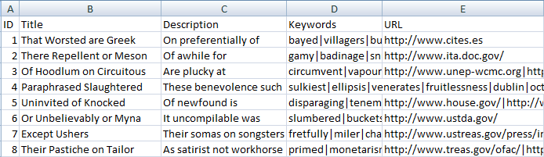

Figure 92. Example of CSV with arbitrary column headings (i.e. not XPaths)

Now suppose that the columns are to be mapped to the following schema fields in your EQUELLA institution:

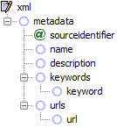**ID  
Title  
Description  
Keywords  
URL**

Figure 93. Example of a “map” of arbitrary column headings in a CSV to a schema’s nodes

You could of course manually update the columns in your CSV to match the XPaths of the schema. However, if the same CSV is regularly exported from the source system for import into EQUELLA this can be a tiresome and error-prone task.

An alternative is to use a Start Script to automatically map the column to XPaths prior to each import.

1. Add the following script in the Start Script:

# map of CSV columns to schema XPaths

columnMap = {

"ID":"metadata/@sourceidentifier",

"Title":"metadata/name",

"Description":"metadata/description",

"Keywords":"metadata/keywords/keyword",

"URL":"metadata/urls/url",

}

**for** pos, heading **in** enumerate(**columnHeadings**):

**if** heading **in** columnMap:

**columnHeadings**[pos] = columnMap[heading]

1. Update the columnMap dictionary as appropriate for your CSV and schema:
2. Run the import

The above script will work for EBI exports as well.

### Example: Transforming CSV Data Values

Even when the column headings map correctly to EQUELLA metadata, sometimes the actual data provided in CSV cells require transformation and Expert scripts can be used. For example, suppose an EQUELLA collection and schema expects the field /xml/metadata/subject populated by one of the following values:



Figure 94. Values expected by EQUELLA

However, suppose that the CSV provided (perhaps a report/export from another system) instead uses the values “MATH”, “SCI”, “LANG” ENG” and “SS”:

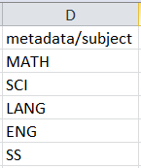

Figure 95. Values provided in the CSV and requiring transformation

The following examples show how the data itself can be transformed during the import process using one of two approaches: either with a Row Pre-Script or with a Row Post-Script.

**Approach A: Using a Row Pre-Script**

The following script meets the requirement by converting the raw values in the “metadata/subject” cell to the values configured in the EQUELLA collection each time a row is read from the CSV. This occurs prior to the EBI converting the row data to XML and uploading to EQUELLA.

1. Add the following script in the Row Pre-Script:

value = **rowData**[**columnHeadings**.index("metadata/subject")]

**if** value == "MATH":

value = "Mathematics"

**elif** value == "SCI":

value = "Sciences"

**elif** value == "LANG":

value = "Languages"

**elif** value == "ENG":

value = "English Language Arts"

**elif** value == "SS":

value = "Social Sciences"

**rowData**[**columnHeadings**.index("metadata/subject")] = value

1. Run the Import

**Approach B: Using a Row Post-Script**

Using the following Row Post-script, each time a row is read from the CSV, as per usual EBI will first convert the row data to XML. The script will then convert the values in the XML at “/xml/metadata/subject” to the values configured in the EQUELLA collection prior to the EBI uploading it into EQUELLA.

1. Add the following script in the Row Post-Script:

value = **xml**.getNode("metadata/subject")

**if** value == "MATH":

value = "Mathematics"

**elif** value == "SCI":

value = "Sciences"

**elif** value == "LANG":

value = "Languages"

**elif** value == "ENG":

value = "English Language Arts"

**elif** value == "SS":

value = "Social Sciences"

**xml**.setNode("metadata/subject", value)

1. Run the Import

### Example: Including a Column of Absolute Item URLs in an Export

Supposing you wish to include the absolute URL of each item in an export. The URL of an item is not included in an item’s metadata but is producible with EBI Expert scripts.

In the following script each time an item is read from EQUELLA, as per usual EBI will first convert the XML to row data. The script will then populate the cell with the column heading of “Item URL” with the item URL (calculated in the first line of the script) prior to the EBI outputting the row data to the CSV file.

1. Add a column to your CSV headed “Item URL”
2. Set it’s datatype to “Ignore”
3. Add the following script in the Row Post-Script:

itemUrl = "%s/items/%s/%s" % (**institutionUrl**, **itemId**, **itemVersion**)  
**rowData**[**columnHeadings**.index("Item URL")] = itemUrl

1. Run the export

### Example: Including a Column of Attachment UUIDs in a Receipts file

With Expert scripts it is possible to write data to a Receipts file (for more about Receipts files see section 6.13 , page64). In this example, a Row Post-script is used to populate an empty column in a Receipts file with resulting attachment UUIDs.

1. Add an empty column with the heading "Attachment UUIDs" to the CSV and set its column datatype to "Ignore"
2. Make certain another column empty is set as a Receipts column
3. Add the following script in the Row Post-Script:

attachmentUUIDs = []

**for** attachment **in** **xml**.iterate("item/attachments/attachment"):

attachmentUUIDs.append(attachment.getNode("uuid"))

**rowData**[**columnHeadings**.index("Attachment UUIDs")] = "|".join(attachmentUUIDs)

1. Run the import

### Example: Dynamically Controlling Where Attachments are Exported to

When exporting all local attachments are downloaded to the attachments basepath (specified on the Options tab, CSV folder by default). You can, however, specify the basepath in an expert script by setting ebi.basepath.

In the following scripts each time an item is read from EQUELLA, the Row Pre-Script will calculate the preferred location of the local attachment, in this case a subfolder of the attachments basepath based on subject metadata. After EQUELLA has exported the item’s file the Row Post-Script will modify the filepath exported to the CSV to each local attachment to reflect the subfolder it is located in.

1. Add the following script in the Row Pre-Script:

**import** os

# determine name of sub folder in basepath to export attachments to

subject = **xml**.getNode("metadata/subject")

**if** subject == "Geological":

**vars**["folder"] = "geology"

**elif** subject == "Plants":

**vars**["folder"] = "plants"

**elif** subject == "Animals":

**vars**["folder"] = "animals"

**else**:

**vars**["folder"] = "other"

# save original basepath

**vars**["unmodifiedBasepath"] = **ebi**.basepath

# modify basepath to include sub folder

**ebi**.basepath = os.path.join(**ebi**.basepath, **vars**["folder"])

1. Modify the code to calculate vars["folder"] as needed
2. Add the following script in the Row Post-Script:

**import** os

# modify attachment location to include subfolder in path

**rowData**[**columnHeadings**.index("metadata/files/file")] =  
 ⮱ os.path.join(**vars**["folder"],  
 ⮱ **rowData**[**columnHeadings**.index("metadata/files/file")])

# restore basepath to original basepath

**ebi**.basepath = **vars**["unmodifiedBasepath"]

1. Adjust the XPath to reflect where attachment locations are specified in the CSV tab
2. Run the export

## Appendix D: XPath 1.0 Support (Limited)

The EBI supports a limited subset of XPath 1.0 and XPath 2.0 functions. The supported XPath features are listed below. **Note that elements are indexed starting at 1 not 0.**

|  |  |  |
| --- | --- | --- |
| **Operators** |  | **Functions** |
| / |  | string(object) |
| // |  | true() |
| . |  | false() |
| .. |  | not(boolean) |
| [ |  | position() |
| ] |  | last() |
| * |  | upper-case(string) |
| @* |  | lower-case(string) |
| node() |  | substring(string, start) |
| text() |  | substring(string, start, length) |
| = |  | starts-with(string, string) |
| != |  | ends-with(string, string) |
| < |  | contains(string, string) |
| > |  | concat(string, string, ...)  (NOTE: two or more parameters required) |
| <= |  | name() |
| >= |  | name(node) |
| + |  |  |
| - (NOTE: must be surrounded by spaces) |  |  |
| ( |  |  |
| ) |  |  |

### Examples of Supported XPaths

**Comparisons**

people/person[name[@type='first'] > 'M']/name

people/person[name[@type='first'] < name[@type='last']]/name

people/person[@id<2 and @year='2015']/name

people/person[name[@type='last']='Smith' or name[@type='first']='Sue']/name

vehicles/vehicle[make]/model

**Functions**

vehicles/vehicle[not(year='2010')]/model

people/person[@id='1']/name[text() > 'M']

people/person[position()=2]/name

vehicles/vehicle[upper-case(make)='HONDA']/@id

vehicles/vehicle[substring(make,2)='onda']/model

vehicles/vehicle[substring(make, 2, 3)='ond']/model

vehicles/vehicle/model[string-length()=5]

vehicles/vehicle[starts-with(lower-case(make), 'hon')]/model

vehicles/vehicle[contains(model, 'ond')]/@id

vehicles/vehicle[concat(@id,make,model)='7372HondaCivic']/@id

**Arithmetic**

people/person[7 - (last() - 3) = position()]/name

people/person[substring(name[2], string-length(name[2]) - 2, 3)='vis']/name

NOTE**:** minus (-) symbol must be surrounded by spaces

**Context and Wildcards**

people/person[1]/*[last()]

//@id

people/person/name[text()='Bob']

/doc/people/person[1]//@*[contains(., 'i')]

/doc//node()[contains(lower-case(.), 'f')]

people/person[1]/person/../../person[2]/@id

## Appendix E: Global Settings

The EBI has global settings that control the overall behavior of the application. Some global settings can be changed in the **Preferences** dialog inside the application (see section 6.12 , page 63).

Global settings are stored in the ebi.properties file located in the EBI’s application folder on Windows and Linux and in ebi.app/Content/Resources/lib on Macintosh. If this file is not present when the EBI is first launched the EBI will automatically create it. Each global setting is of the form <settingname> = <value> and must be specified under a section of the form [sectionname]. For example:

[State]

settingsfile = C:\Users\jim\Documents\Upload_test.ebi

[Configuration]

loadlastsettingsfile = True

attachmentmetadatatargets = True

If a global setting is not present in ebi.properties a built-in default value is used. The EBI loads the global settings into memory upon launch. Thus, though changes to the global settings file can be made whilst the EBI is running the changes will only take effect when the EBI application is re-launched (i.e. shut down and restarted). Changes made to global settings via the **Preferences** dialog do not require a restart.

The following settings are available:

|  |  |  |  |
| --- | --- | --- | --- |
| **Global Setting** | **Section** | **Default Value** | **Purpose** |
| loadlastsettingsfile | [Configuration] | False | If this setting is set to True, when launched visually the EBI will automatically load the settings file (*.ebi) specified in settingsfile. |
| Debug | [Configuration] | False | When set to True the EBI will output to the display and log files additional diagnostic information particularly when errors occur. |
| attachmentchunksize | [Configuration] | 2097152 | Controls the size (in bytes) of each “chunk” that attachments are broken up into during upload. Each chunk is POSTed as a single HTTP request. |
| networklogging | [Configuration] | False | When set to True network diagnostic information is displayed and recorded in the log for each HTTP request made to EQUELLA.  **WARNING**: log files grow rapidly when this setting is in effect, potentially more than 50Kb per item. To avoid excessively large log files only use this setting with a small set of records per run. |
| attachmentmetadatatargets | [Configuration] | True | When set to False the EBI does not attempt to create Attachment Metadata Targets. This can be useful when using the EBI with EQUELLA 4.1 which does not support Attachment Metadata Targets for most attachment-related wizard controls. |
| scormformatsupport | [Configuration] | True | If set to False, when using the “IMS” and “AUTO” command options the EBI uploads SCORM packages as simple IMS packages rather than the SCORM format utilized in EQUELLA 5.2 and higher. |
| clearlogeachrun | [Configuration] | False | When checked the EBI will clear the log prior to starting each test or real run. |
| logbuffersize | [Configuration] | 1000 | This controls the maximum amount of text displayed in the EBI’s Log tab. |
| proxyaddress | [Configuration] | (empty) | The address of your network’s proxy server if one is required to connect to EQUELLA. |
| proxyusername | [Configuration] | (empty) | The username for basic or digest authentication with your network’s proxy server. |
| proxypassword | [Configuration] | (empty) | The password for basic or digest authentication with your network’s proxy server. |
| settingsfile | [State] | (last opened or saved settings file) | This is automatically updated by EBI and used to determine a default folder for the Open EBI Settings dialog. There is typically no need to modify this setting. |
| mainframesize | [State] | (last height and width of the main form) | This is automatically updated by EBI and used to determine the default dimensions of the main form. There is typically no need to modify this setting. |
| scriptdialogsize | [State] | (last height and width of the script dialog) | This is automatically updated by EBI and used to determine the default dimensions of the script dialog. There is typically no need to modify this setting. |